**PERIODIC TABLE: TOPIC TRENDS**

In this course, you will discover and predict the most fashionable periodic properties. All of them related to the electronic configuration of chemicals elements.

1. **THE TOPIC TRENDS FOR ATOMIC RADIUS**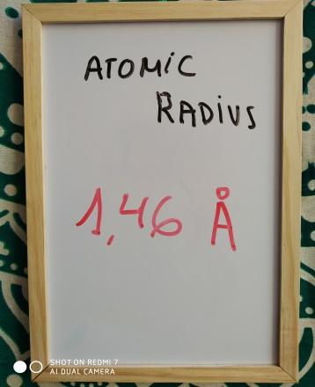

Atomic radius is generally stated as being the total distance from an atom’s nucleus to the outermost orbital of electrons.

As you begin to move across or down the periodic table, trends emerge that help explain how atomic radii change.

* 1. **ELEMENTS ARRANGED IN GROUP**

For members of the nitrogen family, determine the trend that exists between the period and the atomic radius.

Complete the table and chart.

|  |  |  |
| --- | --- | --- |
| **PERIOD** | **ELEMENT** | **ATOMIC RADIUS** |
| 2 | Nitrogen |  |
|  |  |  |
|  |  |  |
|  |  |  |
|  |  |  |

As you go down a column, the atomic radius ______________

**1.2 ELEMENTS ARRANGED IN THE SAME PERIOD**

For elements in row three, determine the trend that exists between the family and the atomic radius.

Complete the table and chart.

|  |  |  |
| --- | --- | --- |
| **FAMILY** | **ELEMENT** | **ATOMIC RADIUS** |
| 1 | Sodium |  |
|  |  |  |
|  |  |  |
|  |  |  |
|  |  |  |
|  |  |  |
|  |  |  |

As you go across a period, the atomic radius _______________

* 1. **YEARS AND NATIONS OF THE ELEMENTS DISCOVERY**

This is the periodic table with the nations where chemical elements were discovered.

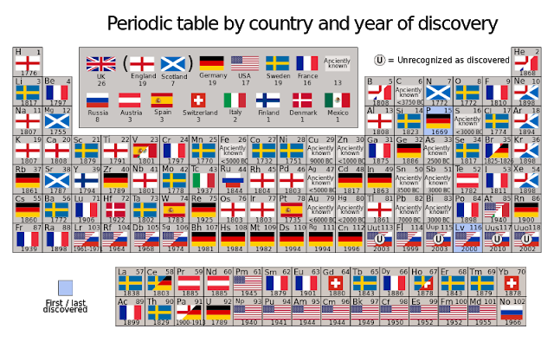

Find which are the nationalities of the previous exposed pnictogens family or Nitrogen group.

|  |  |  |
| --- | --- | --- |
| **ELEMENT** | **YEAR** | **COUNTRY OF DISCOVERY** |
| N |  |  |
| P |  |  |
| As |  |  |
| Sb |  |  |
| Bi |  |  |

Complete also the following table in groups of 4 mates:

|  |  |  |
| --- | --- | --- |
| **ELEMENTS** | **COUNTRY OF DISCOVERY** | **CONTINENT** |
| W, Pt, V | Spain | Europe |
|  |  |  |
|  |  |  |
|  |  |  |
|  |  |  |
|  |  |  |
|  |  |  |
|  |  |  |
|  |  |  |
|  |  |  |
|  |  |  |
|  |  |  |
|  |  |  |
|  |  |  |

1. **TOPIC TRENDS FOR IONIZATION ENERGY**

Ionization energy is the minimum energy required to remove an electron from an atom or ion in the gas phase.

X(g) + energy → X+(g) + e−  1st ionization energy

The most common units of ionization energy are kilojoules per mole (kJ/M) or electron volts (eV), and always positive values.

Ionization energy exhibits periodicity on the periodic table.

* 1. **ELEMENTS ARRANGED IN GROUP**

Determine the trend that exists between the period and the ionization energy for noble gases.

Complete the table and chart.

|  |  |  |
| --- | --- | --- |
| **Elements** | **Period** | **1st Ionization energy (eV)** |
| **He** |  |  |
| **Ne** |  |  |
| **Ar** |  |  |
| **Kr** |  |  |
| **Xe** |  |  |
| **Rn** |  |  |

As you go down a column, the ionization energy _______________________

**2.2 ELEMENTS ARRANGED IN THE SAME PERIOD**

Discover the relationship between the ionization energy and the family number of the element for members of the second shell.

Complete the table and chart.

|  |  |  |
| --- | --- | --- |
| **Elements** | **Family** | **Ionization Energy (eV)** |
| **Li** |  |  |
| **Be** |  |  |
| **B** |  |  |
| **C** |  |  |
| **N** |  |  |
| **O** |  |  |
| **P** |  |  |
| **Ne** |  |  |

As you go across a period, the ionization energy _________________________

1. **THE TOPIC TRENDS FOR ELECTRONEGATIVITY**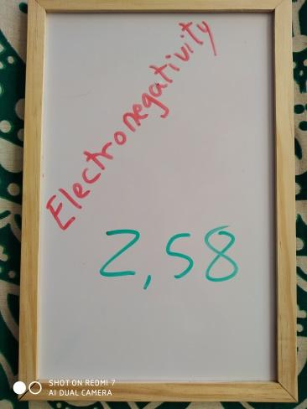

Electronegativity is a measure of how strongly atoms attract bonding electrons to themselves.

Higher the electronegativity is, greater the atom's attraction for electrons.

In fact, electronegativity is:

Electronegativity = (Ionization Energy + Electron Affinity) / 2

Where electron affinity is the amount of energy *released* when an electron is attached to a neutral atom or molecule in the gaseous state to form a negative ion.[[1]](https://en.wikipedia.org/wiki/Electron_affinity#cite_note-Compendiumof-1)

X(g) + e− → X−(g) + energy

By doing the following activities, you will discover the topic periodic trends for electronegativity.

* 1. **ELEMENTS ARRANGED IN GROUP**

For members of the oxygen family, determine the trend that exists between period and electronegativity.

Complete the table and chart.

|  |  |  |
| --- | --- | --- |
| **Elements** | **Period** | **Electronegativity** |
| **O** |  |  |
| **S** |  |  |
| **Se** |  |  |
| **Te** |  |  |
| **Po** |  |  |

As you go down a column, the electronegativity _________________________

* 1. **ELEMENTS ARRANGED IN THE SAME PERIOD**

Discover the relationship between the ionization energy and the family number of the element for members of the third shell.

Complete the table and chart.

|  |  |  |
| --- | --- | --- |
| **Elements** | **Family** | **Electronegativity** |
| **Sodium** |  |  |
| **Magnesium** |  |  |
| **Aluminum** |  |  |
| **Silicon** |  |  |
| **Phosphorus** |  |  |
| **Sulfur** |  |  |
| **Chlorine** |  |  |

As you go across a row, the electronegativity ___________________________

1. **CRAZY TRENDS**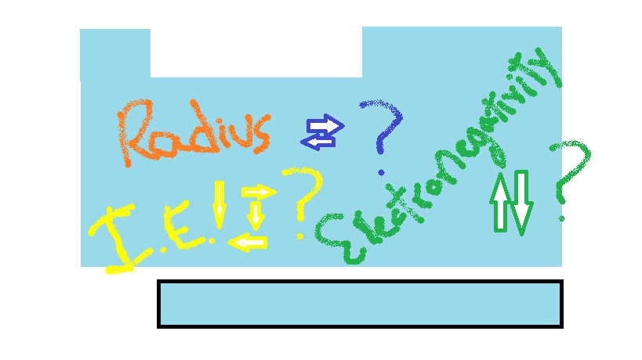

UP / DOWN / IONIZATION / LEFT / INCREASE / RADIUS / RIGHT / DECREASE……….

WHAT A MESS!!!

To order your ideas, fill the gaps in this summary.

**4.1 SUMMARY**

The trend of atomic radius in a group:

As you go down a column, the atomic radius ________

The trend of atomic radius in a period:

As you go across a row, atomic radius ____________

The trend of ionization energy in a group:

As you go down a column, the ionization energy _________

The trend of ionization energy in a period:

As you go across a row, the ionization energy ___________

The trend of electronegativity in a group:

As you go down a column, electronegativity _________________

The trend of electronegativity in a period:

As you go across a row, the electronegativity _______________

Now, you should try to justify why ionization energy varies in this way.

While going down a column; ____________________________________________________________________________________________________________________________________________________________________________________________________________________

While going across a row; ____________________________________________________________________________________________________________________________________________________________________________________________________________________

4.2 TO REALLY, REALLY END THIS TREND TOPIC

Work in groups of 4 students.

Did you know that a few chemical elements were discovered by women?

Your task;

- find which are these elements,

- the years of discovery,

- the name of these women,

- the nacionality of them.