**Light**

In Science and Art

**1st teaching period**

# 1st Activity: What do we know about light?

Duration: 15’

Class organization: the whole class participates, every student on her/his own or in pairs in the art lab. A board (or simply a wall!) is needed for this activity.

Type of activity: whole class discussion: the art teacher is asking triggering questions about the nature of light. The teacher has prepared a large paper surface with a drawing or a cut-out paper shape of the sun. The sun drawing/cut-out is placed on the wall, or on the board, with tape or pins, so that everyone can see it. (Alternatively the teacher asks a student to draw the sun on the board).

Actions/Tasks:

1. Students provide their answers on a sticky-note paper and stick it on the “sun”.

2. A pair of students reads aloud what has been written on the notes.

*A Distance Learning alternative could be a Padlet activity: students may post on the* [*Padlet*](https://padlet.com/palla_eugenia/urv6iy7dbge3c8cd) *their short answers on the questions the teacher asks (“Initial Questions” at* [*Padlet*](https://padlet.com/palla_eugenia/urv6iy7dbge3c8cd)*). Another alternative could be a World cloud activity: On a word cloud generator application, such as Word art.com students provide words that are relevant to light. Computers or tablets and internet connection are needed for both of these activities.*

2nd Activity: Light in Science and Art

Duration: 30’

Class organization: the whole class participates; students are organized in pairs with one or more light sources for each pair and some simple objects they can find in their school bags (eraser, pencil, marker, etc). As lighting sources students may use:

i. Classroom lighting sources-lamps

ii. Flash lights (students could also use flash lights from electronic devices, such as tablets/mobile phones.

iii. Natural light from the windows.

Type of activity: presentation: *Light in Science and Art* (PowerPoint) presented by the teacher, with intervals of experiments by the students on the nature of light and shadow and their use in art. The teacher explains the information presented and asks students to perform specific experiments with different lighting conditions and observe their results (for more details you may see the PowerPoint presentation *“Light in Science and Art”* ).

Actions/Tasks:

1. The students watch the presentation.
2. The students make experiments with light and shadows and discuss their observations

A [glossary](https://quizlet.com/_b2nbx6?x=1qqt&i=6m3w6) is available throughout the lessons

# 3d Activity: Homework (20’)

Students are asked to post their observations οn the [padlet](https://padlet.com/palla_eugenia/urv6iy7dbge3c8cd). Their observations/answers on the nature of light and shadow should respond to [*Questions_1* Experiments with Light and Shadow](https://padlet.com/palla_eugenia/urv6iy7dbge3c8cd) on the padlet).

*An extension, as homework, that would provide further knowledge and understanding on the nature of light would be to ask students to watch a longer video:* [*https://www.khanacademy.org/science/hs-physics/x215e29cb31244fa1:electromagnetic-radiation/x215e29cb31244fa1:wave-particle-duality/v/introduction-to-light*](https://www.khanacademy.org/science/hs-physics/x215e29cb31244fa1:electromagnetic-radiation/x215e29cb31244fa1:wave-particle-duality/v/introduction-to-light) *(and answer a few questions on a worksheet, or padlet).*

**2nd teaching period**

# 1st Activity: Worksheet: *Let’s see what you remember!*

Duration: 20’

Class organization: the whole class participates, every student on her/his own

Type of activity: Students fill in the [worksheet](https://www.canva.com/design/DAE2jeoE4rI/ygo246PwlTNasmjwnoh5Cw/view?utm_content=DAE2jeoE4rI&utm_campaign=designshare&utm_medium=link&utm_source=sharebuttonjwnoh5Cw/view?utm_content=DAE2jeoE4rI&utm_campaign=designshare&utm_medium=link&utm_source=sharebutton). *Let's see what you remember! (10’).* After they finish answering the questions, the teacher reads them aloud and students provide their answers. The whole class discusses the answers (10’).

Actions/Tasks:

1. Students fill in a worksheet.
2. Students discuss their answers

# 2nd Activity: Video watching

# Duration: 3’-8’

Class organization: the whole class participates

Type of activity: The class watches the video: [*Newton's Light Spectrum Experiment* , by BBC Earth](https://www.youtube.com/watch?v=--b1F6jUx44) Lab(2,46’), or the video: [*Newton’s prism experiment*](https://www.khanacademy.org/science/in-in-class10th-physics/in-in-the-human-eye-and-the-colourful-world/in-in-dispersion-of-light-in-prism/v/newton-prism-experiment), by Khan Academy (7,40), or [*Newton’s prism experiment*](https://www.khanacademy.org/partner-content/mit-k12/mit-k12-science/mit-k12-physics/v/newtons-prism-experiment), by Khan Academy (5,49)

# 3d Activity: Worksheet on the video and discussion

# Duration: 17’-22’, depending on the duration of the chosen video.

Class organization: the whole class participates organized in couples.

Type of activity: Students work in pairs and answer the questions of the [Worksheet](https://www.canva.com/design/DAE2jl-XBVo/l1m4-kC2cGHcfO8VUE-5mA/view?utm_content=DAE2jl-XBVo&utm_campaign=designshare&utm_medium=link&utm_source=sharebutton) 2: *Newton’s Light Spectrum Experiment.* Afterwards the teacher reads the questions, students present their answers and discuss.

*Alternatively a teacher paced quiz is prepared.*

Actions/Tasks:

1. Students answer questions and present their answers to the class.

**3rd teaching period**

# 1st Activity: Light and volume

Duration: 15’

Class organization: the class is organized in groups of 4-6 around big working tables or desks in the school’s art lab. The art teacher has, in advance, placed on each table a round white object (such as a polystyrene-styrofoam sphere, a ping-pong ball, etc.). Every student should have a ruler, white drawing papers, a soft drawing pencil (2B is appropriate), and erasers (pencil eraser and soft, charcoal eraser).

Type of activity: In the art lab the students see the presentation Light in Science and Art are asked to create a small tonal scale (image 1) on a piece of paper with soft drawing pencil (2B), from pure black (total absence of light) to pure white (the strongest possible light). In between black and white, they make three different tones of gray (to represent different shadows). They start by creating a small rectangular shape -using a ruler- ( 2cm wide and 10cm long), separated by very light lines in five squares 2×2cm. In the first square the students should make a totally black tone, in the second a dark gray, in the third a lighter gray, in the fourth a very light gray, and the fifth square should be left blank, white (the brightest light!).

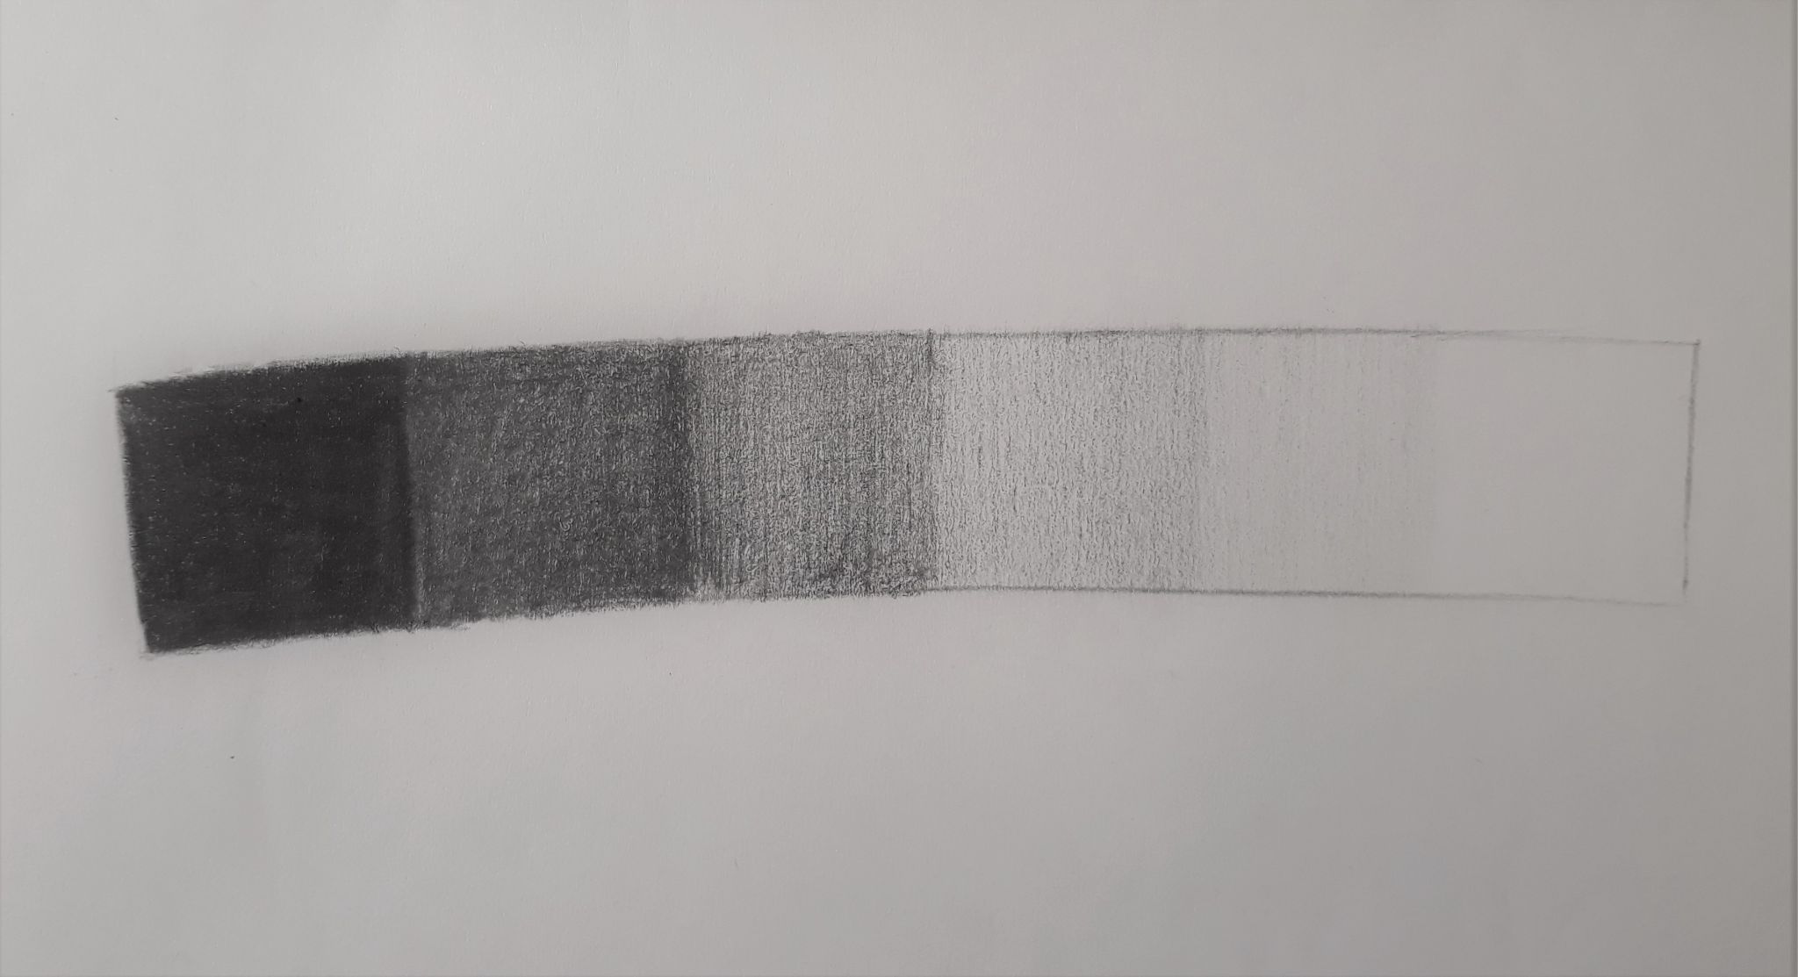

*Image 1. Tonal scale/grayscale*

Actions/Tasks:

1. Students make a rectangle with a ruler, 2cm wide and 10cm long, and divide it in squares of the same size (2×2cm).
2. Students create inside the rectangle a tonal scale with black and three different tones of gray in each square, with a 2B drawing pencil..

# 2nd Activity: Still life drawing-Light and shadows to create volume

# Duration: 30’

# Class organization: the class is organized in groups of 4-6, around big working tables or desks in the school’s art lab. (Before the previous activity the art teacher has placed on each table a round white object, such as a polystyrene/styrofoam sphere, a ping-pong ball, etc. The art teacher has placed the objects on a white paper, sticking their base with a small piece of tape, so that they will not roll on the desk). The teacher chooses the light, depending on the lighting sources available in the classroom. Every student should have white drawing paper, a soft drawing pencil (2B is appropriate), and erasers (pencil eraser and soft, charcoal eraser).

# Type of activity: Hands on activity-Students observe small round objects and draw, with their soft pencils on their paper, the basic shape, the light and the shadows they see from their own point of view. They are asked to use all the tones of gray, the ones they created for the tonal scale activity. They should try to represent on their drawing the shape and tonality of the primary and cast shadow(s).They are also asked to take care that each tone will smoothly change to a lighter one, in order to create the illusion of volume, in other words to create a three-dimensional effect on the two dimensional paper surface.

# Actions/Tasks:

1. Students observe and draw objects-still life drawing-using the tonal scale, to reveal the volume in their drawings.

# 3d Activity: Homework-Presentation and comments

# Duration: 15’

# Class organization: homework-every student on her/his own.

# Type of activity: Students photograph and post their drawings of tonal scale and still life drawings of white objects to Padlet. They make comments about the observations on light and shadow, as important factors to create the illusion of volume.

Actions/Tasks:

1. Students photograph their drawings
2. They post photographs and comments on the [Padlet](https://padlet.com/palla_eugenia/urv6iy7dbge3c8cd)

Extension

1. Students may, for a second time, watch the second part of the ppt presentation Light in Science and Art (specifically slides 17, 18 and 20) before observing the real 3D objects and drawing the shadows. Thus they will refresh their knowledge on light and shadow and be more certain about what they will have to observe and draw.
2. Students may watch a [video](https://www.youtube.com/watch?v=V3WmrWUEIJo&t=405s) on how to draw the shadows on a spherical object, before observing the real objects in the art lab.
3. During another teaching period, students may observe and draw with pencil other, more complicated 3D objects and their primary and cast shadows.
4. Drawing Light and Shadows/ homework:

Duration: 30’

Class organization: students work alone at home.

Type of activity: Students are asked to study a simple object at home, such as a monochromatic cup, or bowl and draw the shapes and tones of the shadows. Students write down observations from the experiments on light and shadow, and post them on a “wall”, on a free application, such as a Padlet page.

Assesment

<https://www.canva.com/design/DAE2jl-XBVo/l1m4-kC2cGHcfO8VUE-5mA/view?utm_content=DAE2jl-XBVo&utm_campaign=designshare&utm_medium=link&utm_source=sharebutton>

<https://wordwall.net/el/resource/28795220>

<https://wordwall.net/el/resource/28795220>

<https://h5p.org/node/1249980?feed_me=nps>