WORKSHEET
TOPIC: Tax havens: International tax avoidance and evasion
CLASS: ……………
NAME: ……………………………………………………
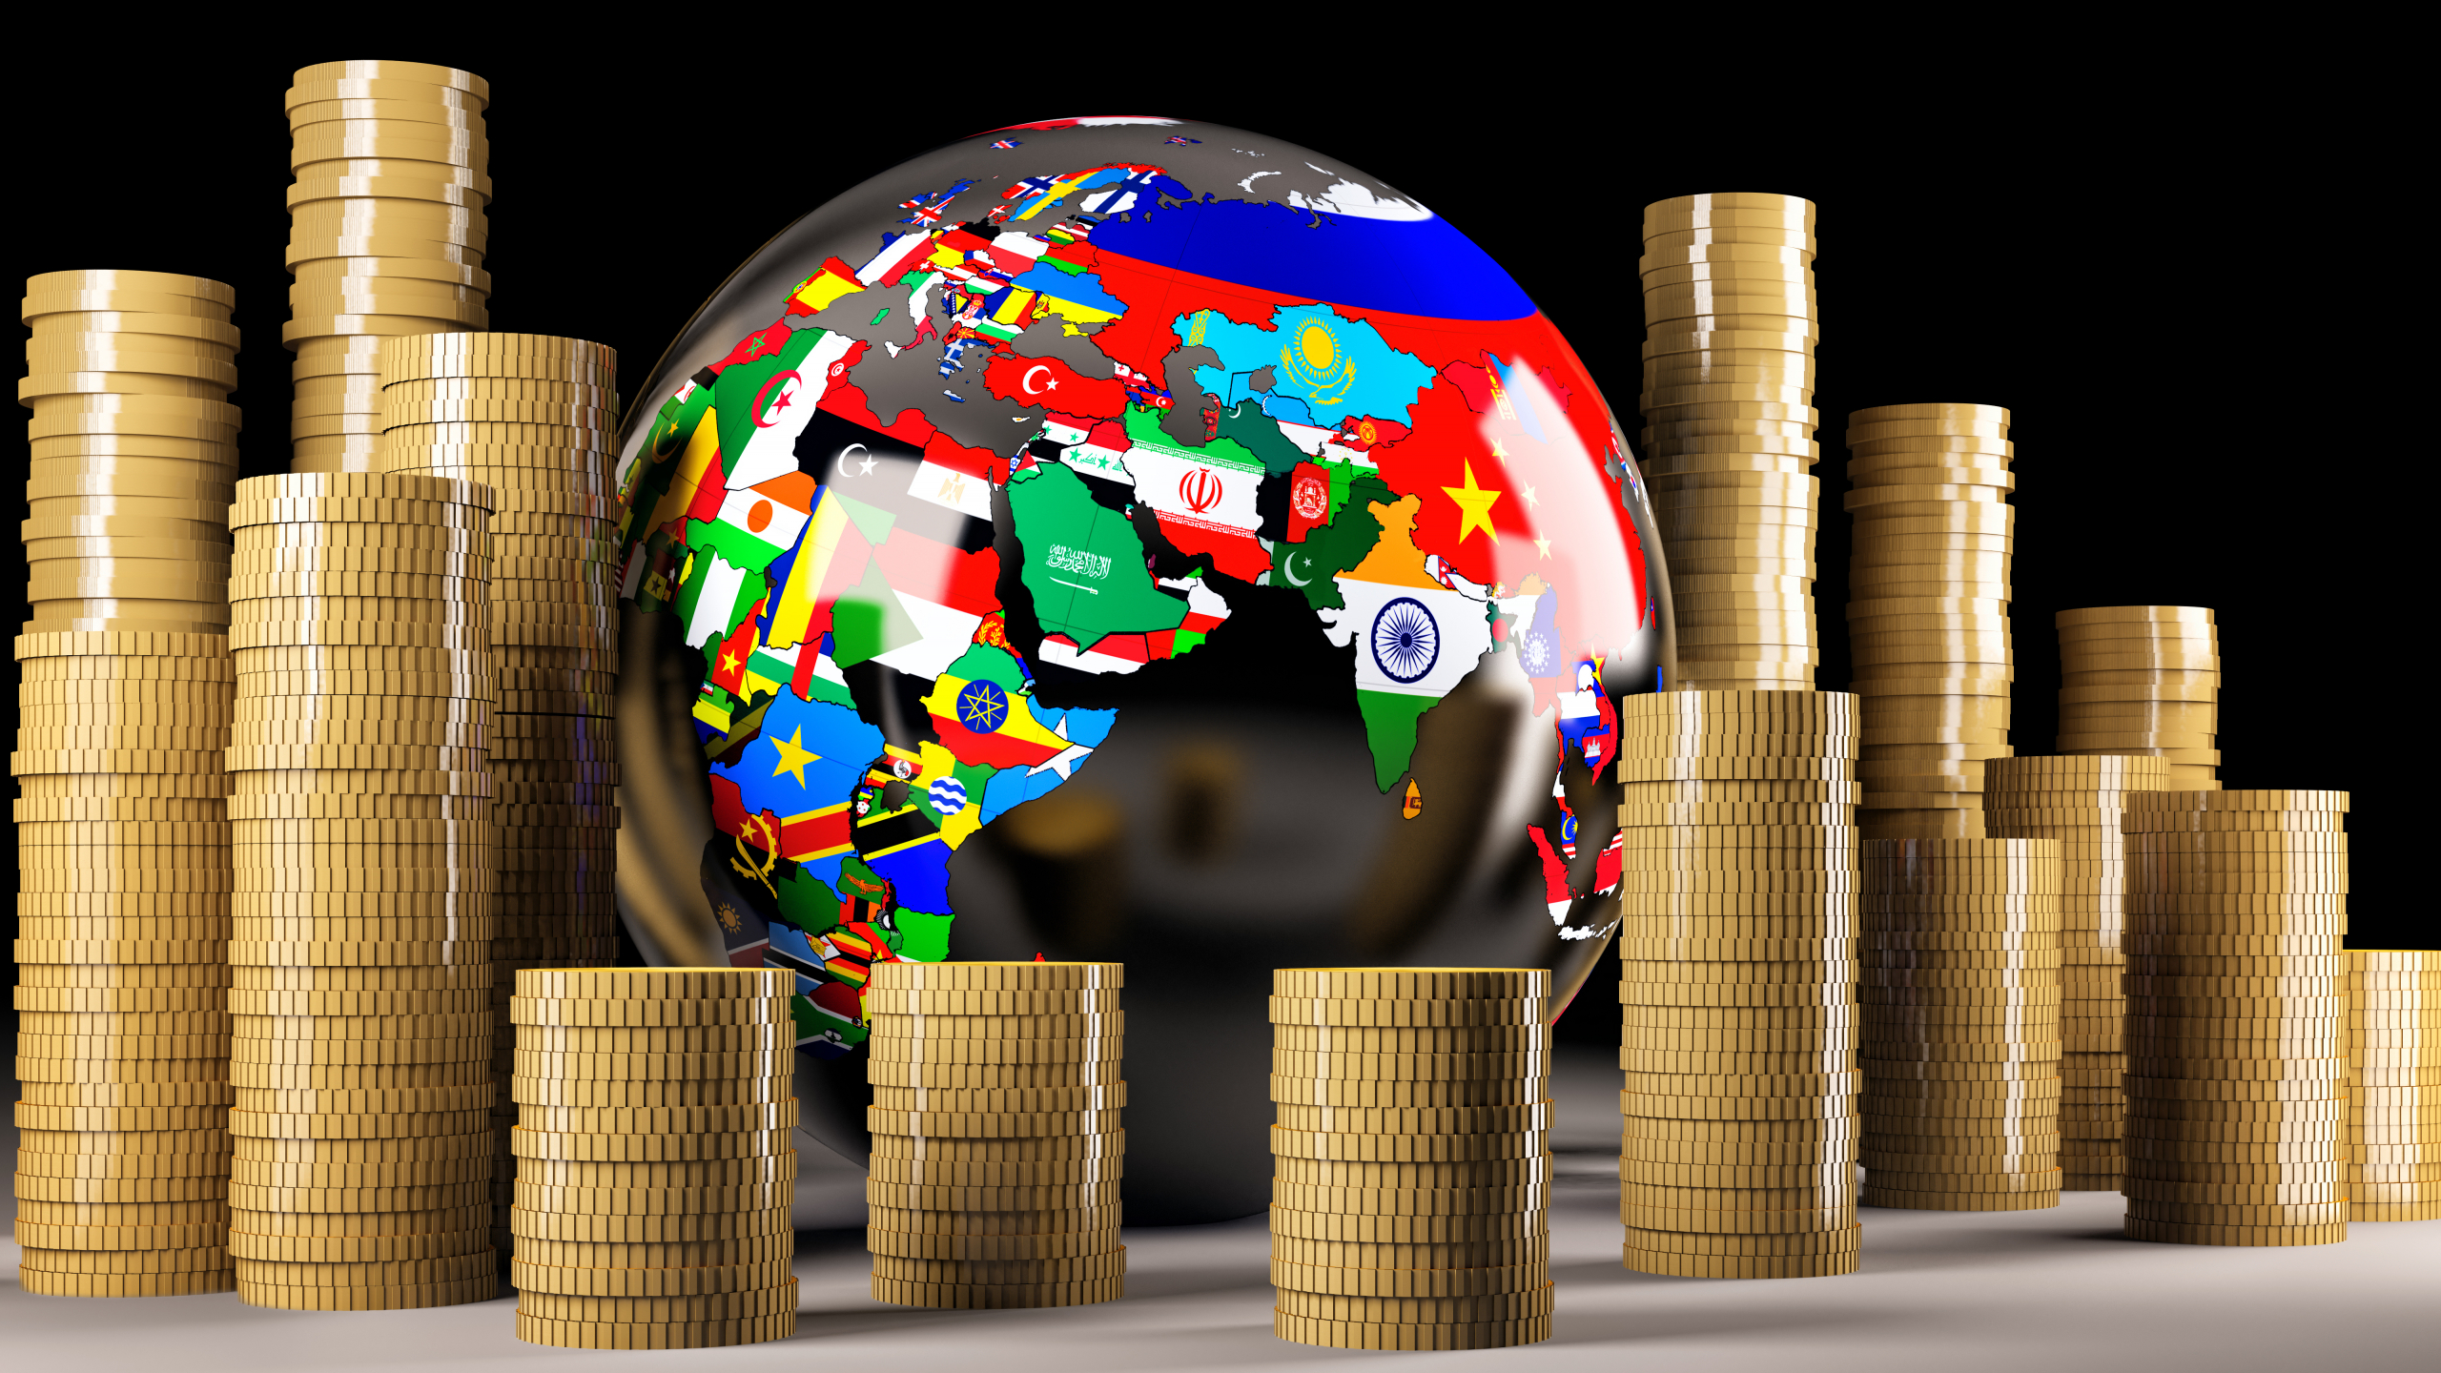
1st Task
Α. What are tax havens and how do they work? Provide an answer, after browsing the following websites.
https://www.youtube.com/watch?v=u9Z9HpP6Fa4
https://www.youtube.com/watch?v=JRlndgfIpb4
Α. …………..………………………………………………………………………………………………………………
……………..………………………………………………………………………………………………………………..
……………..………………………………………………………………………………………………………………..
……………..………………………………………………………………………………………………………………..
Β. Where are the top tax havens? Provide an answer, after browsing the following websites and observing the image below.
https://www.youtube.com/watch?v=dwRfFnckXqM
https://www.visualcapitalist.com/worlds-biggest-private-tax-havens/
https://www.indiatimes.com/trending/social-relevance/best-tax-haven-countries-in-the-world-543364.html
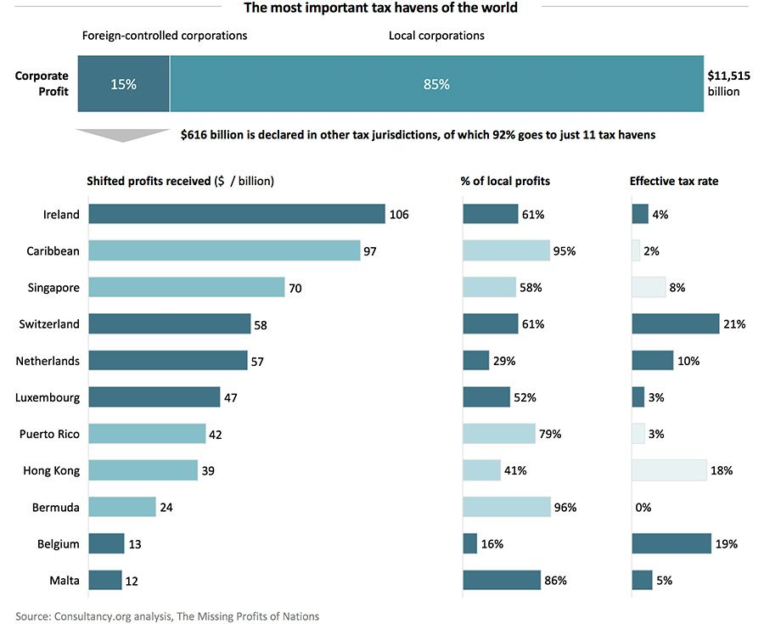
Β. .……………..……………………………………………………………………………………………………………
……………..………………………………………………………………………………………………………………..
……………..………………………………………………………………………………………………………………..
……………..………………………………………………………………………………………………………………..
C. What are offshore companies and why are they created? Provide an answer, after browsing the following web page.
https://marketbusinessnews.com/financial-glossary/offshore-company-definition-meaning/
C. .……………..……………………………………………………………………………………………………………
……………..………………………………………………………………………………………………………………..
……………..………………………………………………………………………………………………………………..
……………..………………………………………………………………………………………………………………..
2nd Task
A. Why should citizens be consistent with their tax liabilities? Provide an answer, after browsing the following websites.
https://www.youtube.com/watch?v=MxgpAzoOTZg
https://www.youtube.com/watch?v=rXzfpIgiQN4
https://www.youtube.com/watch?v=YYUC1vWhtXE
Α. …………..………………………………………………………………………………………………………………
……………..………………………………………………………………………………………………………………..
……………..………………………………………………………………………………………………………………..
……………..………………………………………………………………………………………………………………..
Β. Which taxes are called direct and which ones indirect? Give an example of a tax for each case, after browsing the following websites.
https://www.youtube.com/watch?v=4Gmi_SGtwLk
https://www.youtube.com/watch?v=UTxWeizxFcY
Β. …………..………………………………………………………………………………………………………………
……………..………………………………………………………………………………………………………………..
……………..………………………………………………………………………………………………………………..
……………..………………………………………………………………………………………………………………..

C. After browsing the following websites, answer the following questions.
https://www.youtube.com/watch?v=NW5ABxYUR4w
https://www.youtube.com/watch?v=ClOenRSdPQA
C1. What is the difference between tax evasion and tax avoidance?
……………..………………………………………………………………………………………………………………..
……………..………………………………………………………………………………………………………………..
……………..………………………………………………………………………………………………………………..
C2. What tricks can be used to evade taxes?
……………..………………………………………………………………………………………………………………..
……………..………………………………………………………………………………………………………………..
……………..………………………………………………………………………………………………………………..
……………..………………………………………………………………………………………………………………..
C3. Why is tax evasion considered a deeply anti-social act?
……………..………………………………………………………………………………………………………………..
……………..………………………………………………………………………………………………………………..
……………..………………………………………………………………………………………………………………..
D. Study the following graph (1), which depicts the level of tax rates in Greece and various other European countries.
Graph (1): Top individual income tax rates in Europe.
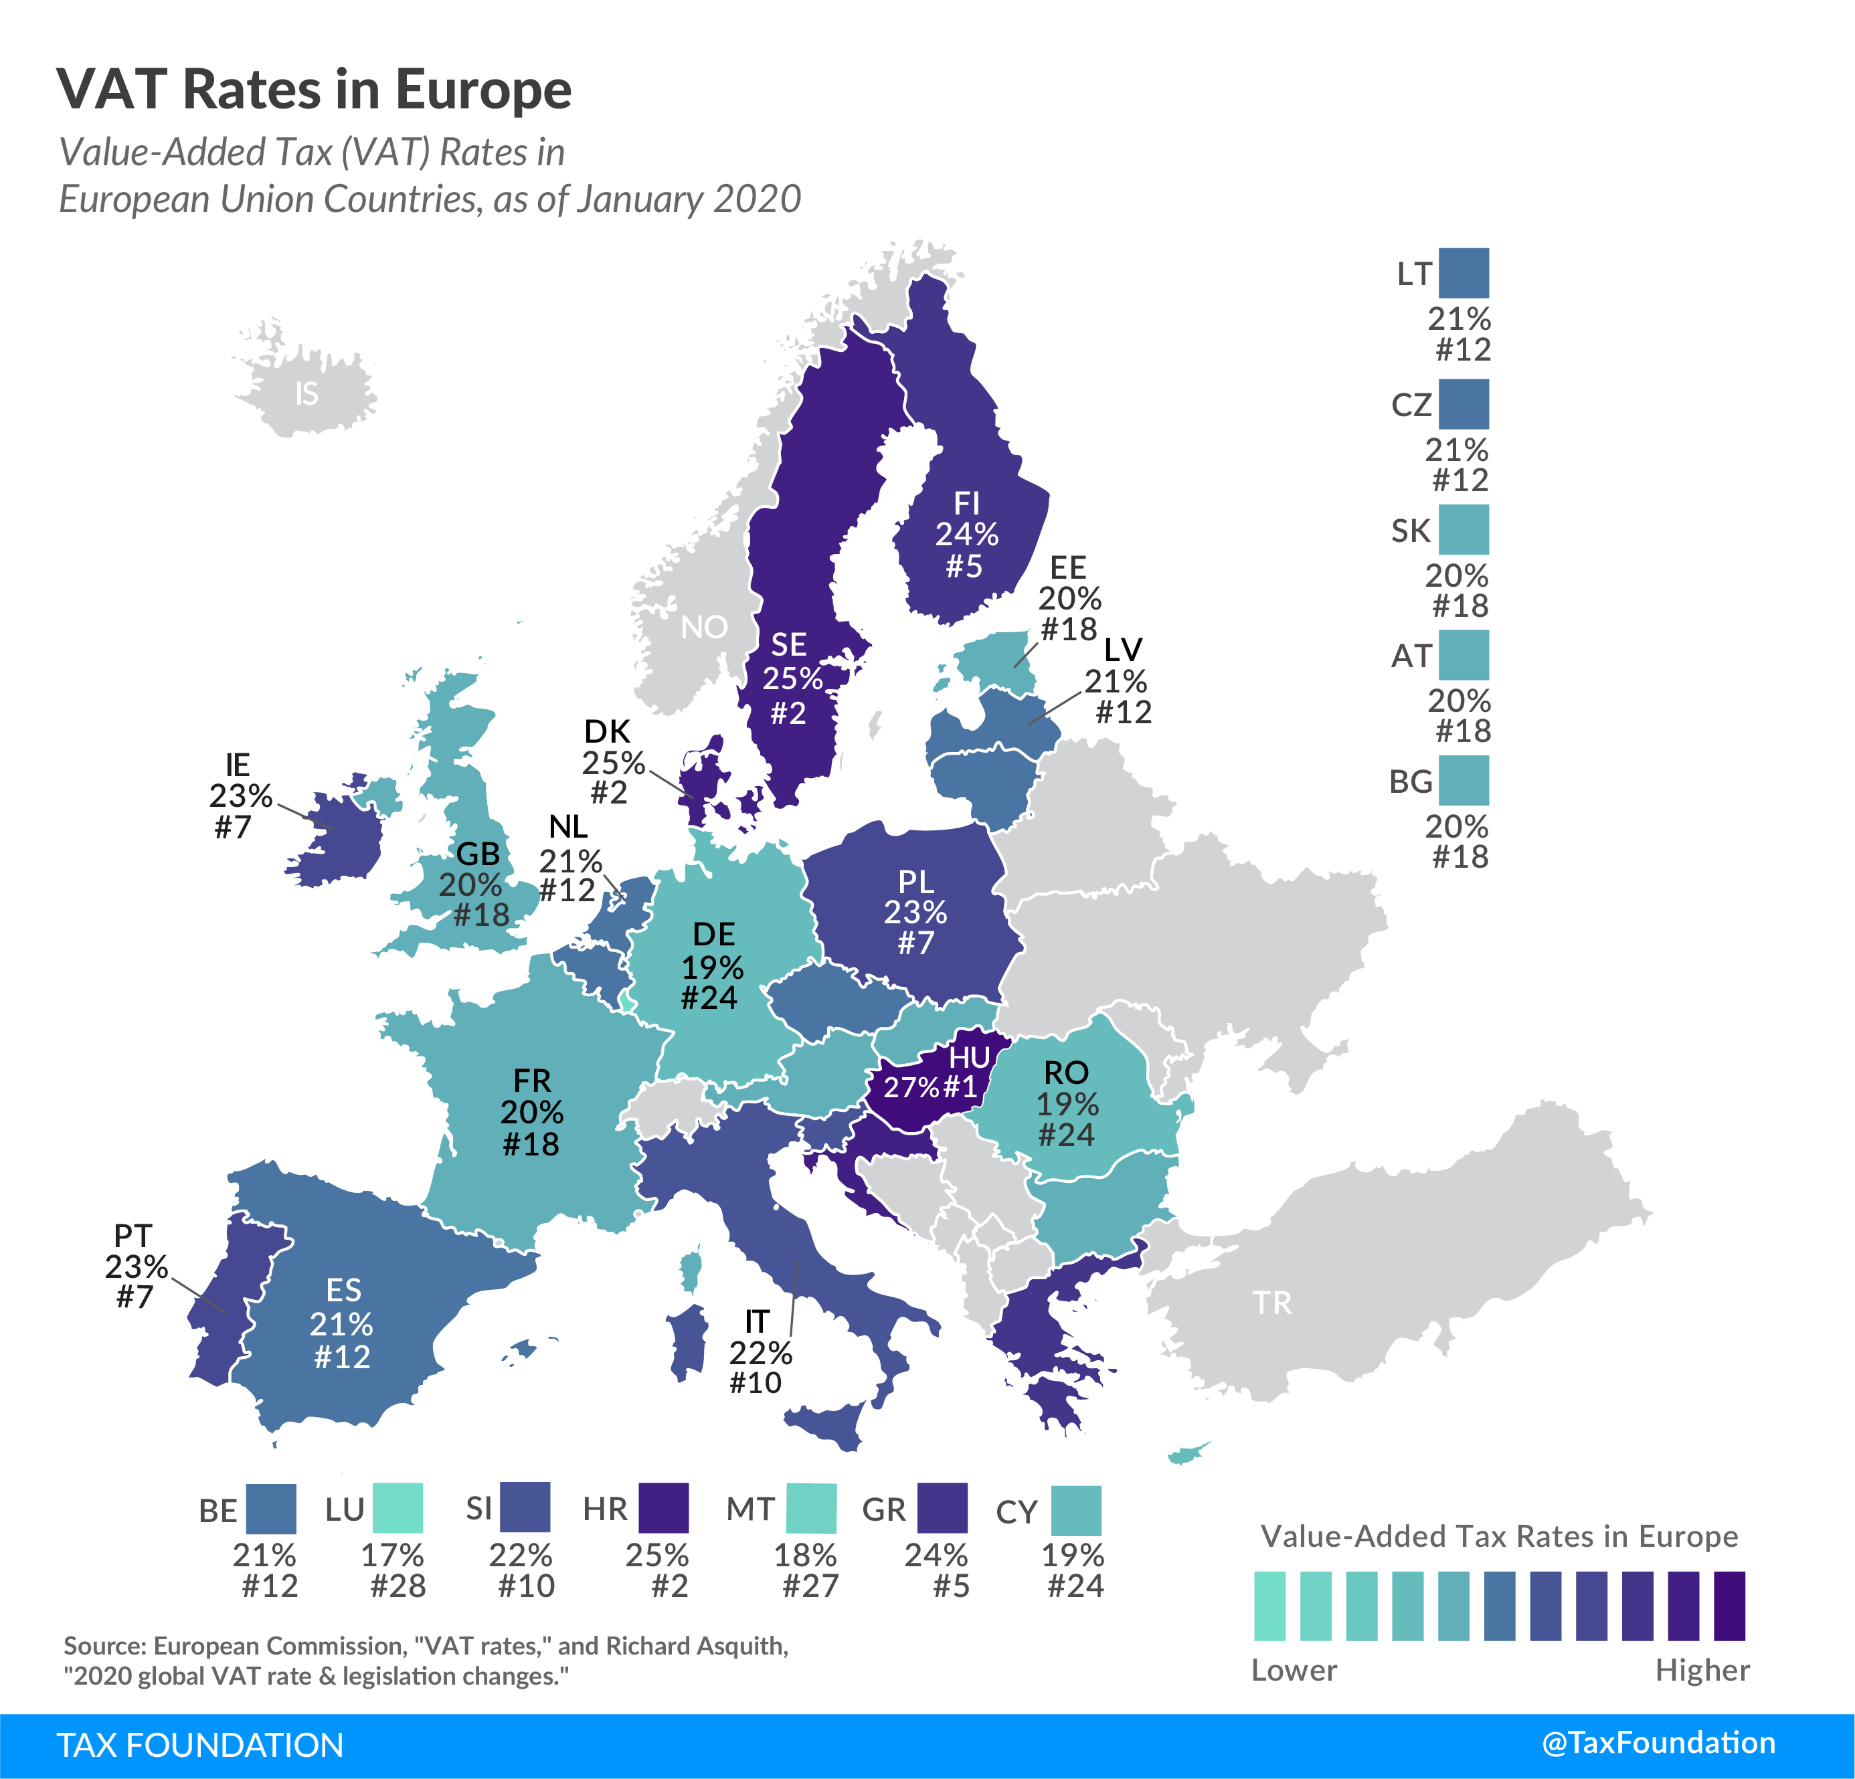
D. What are your conclusions?
……………..………………………………………………………………………………………………………………..
……………..………………………………………………………………………………………………………………..
……………..………………………………………………………………………………………………………………..
3rd Task
Α. Study the following graphs (2 & 3), which show the countries with the highest and lowest corruption rate (Graph 2) as well as the size of shadow economy in the various European countries (Graph 3).
Graph (2): Corruption perceptions index (2019) in the European Countries.
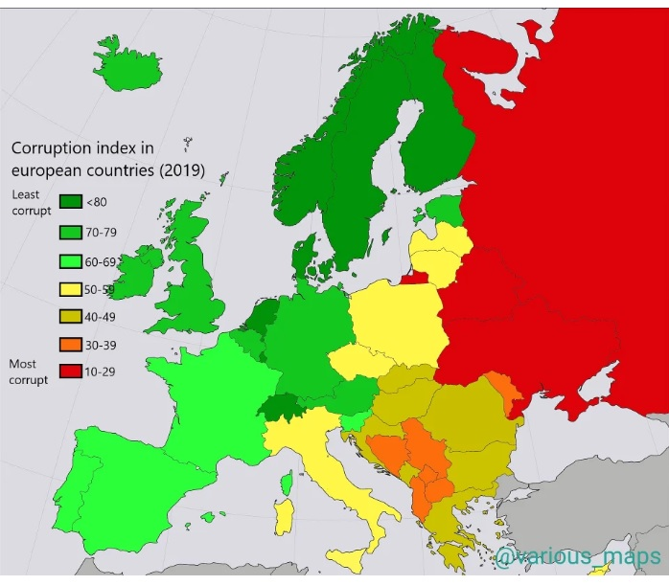
Graph (3): Size of the shadow economy of 31 European countries in 2021.
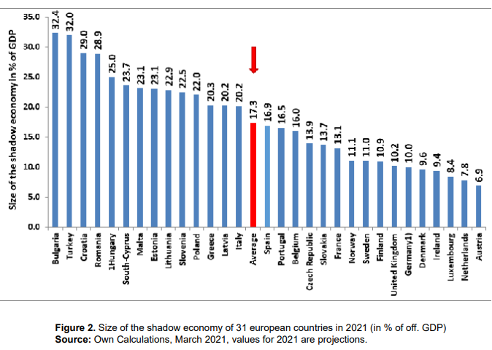
Α1. Which are the five countries with the highest and which ones with the lowest corruption rate?
……………..………………………………………………………………………………………………………………..
……………..………………………………………………………………………………………………………………..
……………..………………………………………………………………………………………………………………..
……………..………………………………………………………………………………………………………………..
Α2. Which are the five countries with the highest percentage and which ones with the lowest percentage of shadow economy?
……………..………………………………………………………………………………………………………………..
……………..………………………………………………………………………………………………………………..
……………..………………………………………………………………………………………………………………..
……………..………………………………………………………………………………………………………………..
Α3. What are your conclusions?
……………..………………………………………………………………………………………………………………..
……………..………………………………………………………………………………………………………………..
……………..………………………………………………………………………………………………………………..
……………..………………………………………………………………………………………………………………..
Α4. How has corruption contributed to the lack of taxpayer compliance?
……………..………………………………………………………………………………………………………………..
……………..………………………………………………………………………………………………………………..
……………..………………………………………………………………………………………………………………..
……………..………………………………………………………………………………………………………………..

