WORKSHEET
TOPIC: Economic crisis: a crisis on our plate?
CLASS: ……………
NAME: ……………………………………………………

TASK 1
Α. After watching the videos below, answer the questions that follow.
https://www.youtube.com/watch?v=HZ8ULuFNMpE
https://www.youtube.com/watch?v=d2T1XxHf-_Q
https://www.youtube.com/watch?v=RyytBOiAP3w
Α1. Explain the concepts involved in financial crises with examples.
……………..………………………………………………………………………………………………………………..
……………..………………………………………………………………………………………………………………..
……………..………………………………………………………………………………………………………………..
……………..………………………………………………………………………………………………………………..
Α2. Describe the social impact of the economic crisis.
……………..………………………………………………………………………………………………………………..
……………..………………………………………………………………………………………………………………..
……………..………………………………………………………………………………………………………………..
……………..………………………………………………………………………………………………………………..
Α3. How can the financial crisis affect the quality of our health?
……………..………………………………………………………………………………………………………………..
……………..………………………………………………………………………………………………………………..
……………..………………………………………………………………………………………………………………..
……………..………………………………………………………………………………………………………………..
TASK 2
Α. After visiting the websites and observing the chart below, answer the questions that follow.
https://www.youtube.com/watch?v=rmF7uJaf1ho
https://www.youtube.com/watch?v=g-ftHcxBx3M
https://www.youtube.com/watch?v=v-fj8ojUmFM
https://www.coe.int/en/web/compass/poverty
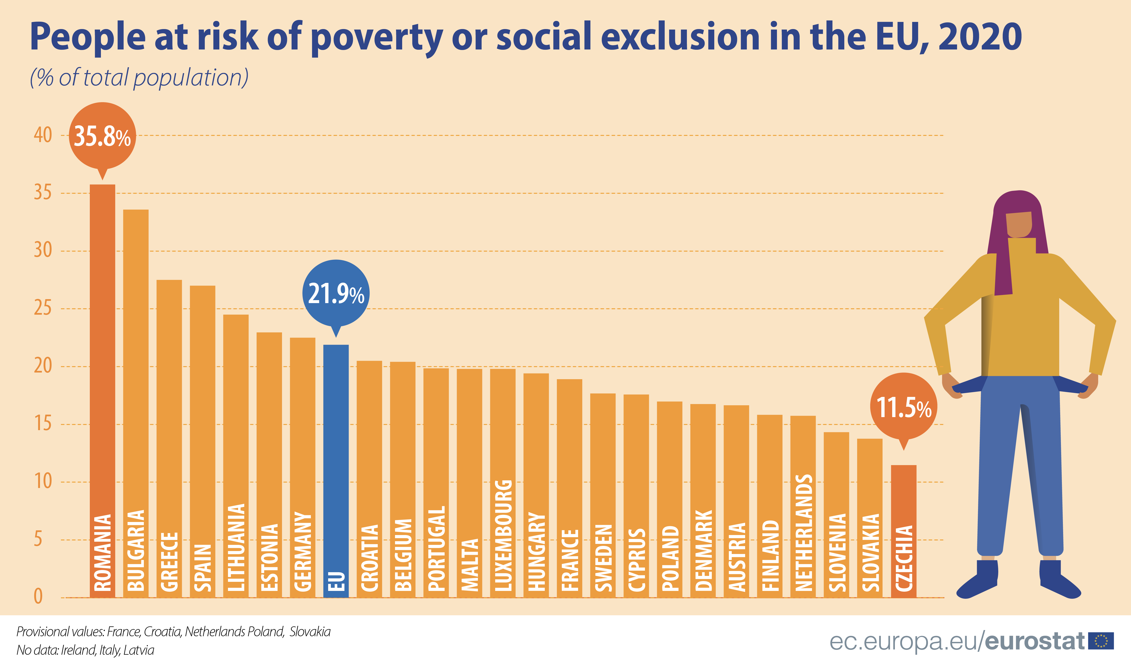

Α1. Explain the difference between absolute and relative poverty.
……………..………………………………………………………………………………………………………………..
……………..………………………………………………………………………………………………………………..
……………..………………………………………………………………………………………………………………..
……………..………………………………………………………………………………………………………………..
Α2. Which are the five countries with the highest and those with the lowest poverty rates in Europe?
……………..………………………………………………………………………………………………………………..
……………..………………………………………………………………………………………………………………..
……………..………………………………………………………………………………………………………………..
……………..………………………………………………………………………………………………………………..
Α3. What measures should the state take to fight poverty?
……………..………………………………………………………………………………………………………………..
……………..………………………………………………………………………………………………………………..
……………..………………………………………………………………………………………………………………..
……………..………………………………………………………………………………………………………………..
TASK 3
Α. Explain the concepts involved in a food crisis with examples, after visiting the website below.
https://businessconnectworld.com/2017/09/13/8-critical-factors-behind-food-crisis/
Α. …………..………………………………………………………………………………………………………………
……………..………………………………………………………………………………………………………………..
……………..………………………………………………………………………………………………………………..
……………..………………………………………………………………………………………………………………..
Β. After visiting the websites and observing the graph below, answer the questions that follow.
https://www.youtube.com/watch?v=8D1jF648HDg
https://www.thebalance.com/why-are-food-prices-rising-causes-of-food-price-inflation-3306099
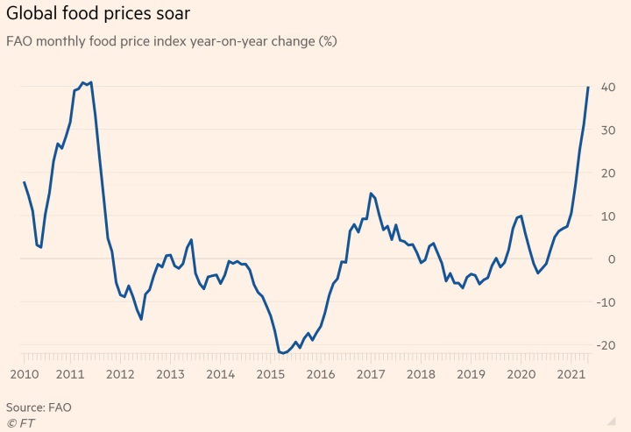
Β1. What conclusions do you make by observing the graph above?
……………..………………………………………………………………………………………………………………..
……………..………………………………………………………………………………………………………………..
……………..………………………………………………………………………………………………………………..
……………..………………………………………………………………………………………………………………..
……………..………………………………………………………………………………………………………………..
Β2. Why are food prices constantly rising?
……………..………………………………………………………………………………………………………………..
……………..………………………………………………………………………………………………………………..
……………..………………………………………………………………………………………………………………..
……………..………………………………………………………………………………………………………………..
……………..………………………………………………………………………………………………………………..
C. In Western societies, economic distress is rarely associated with malnutrition. On the contrary, very often the overall impression is that of weight gain which eventually leads to an increase in obesity. The chart below shows the obesity rates in various European countries.

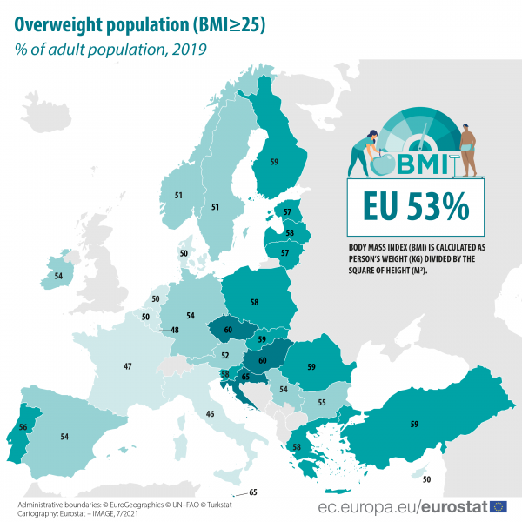

C1. Which are the five countries with the highest and those with the lowest obesity rates in Europe?
……………..………………………………………………………………………………………………………………..
……………..………………………………………………………………………………………………………………..
……………..………………………………………………………………………………………………………………..
……………..………………………………………………………………………………………………………………..
……………..………………………………………………………………………………………………………………..
……………..………………………………………………………………………………………………………………..
C2. In what ways can the financial crisis affect our eating habits? Give relevant examples.
……………..………………………………………………………………………………………………………………..
……………..………………………………………………………………………………………………………………..
……………..………………………………………………………………………………………………………………..
……………..………………………………………………………………………………………………………………..
……………..………………………………………………………………………………………………………………..
……………..………………………………………………………………………………………………………………..
C3. What practical solutions would you suggest for economical and at the same time rational food choices?
……………..………………………………………………………………………………………………………………..
……………..………………………………………………………………………………………………………………..
……………..………………………………………………………………………………………………………………..
……………..………………………………………………………………………………………………………………..
TASK 4
Α. Observe the two pyramids (Healthy Eating and Mediterranean Diet) and identify the main similarities and differences.
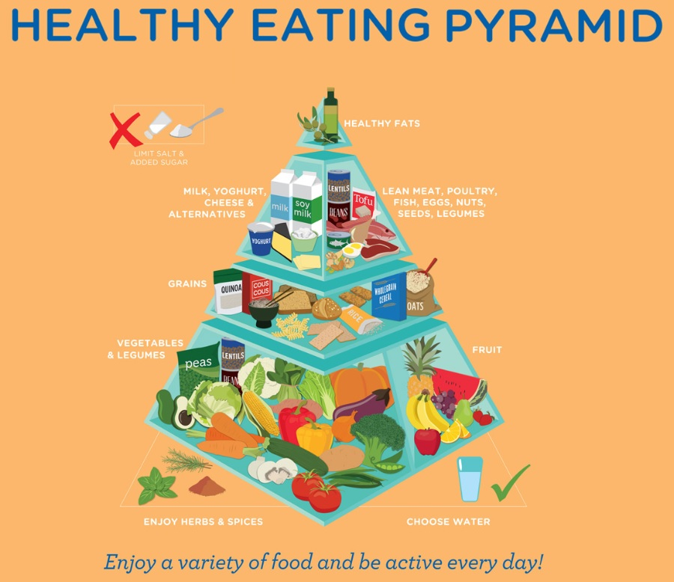
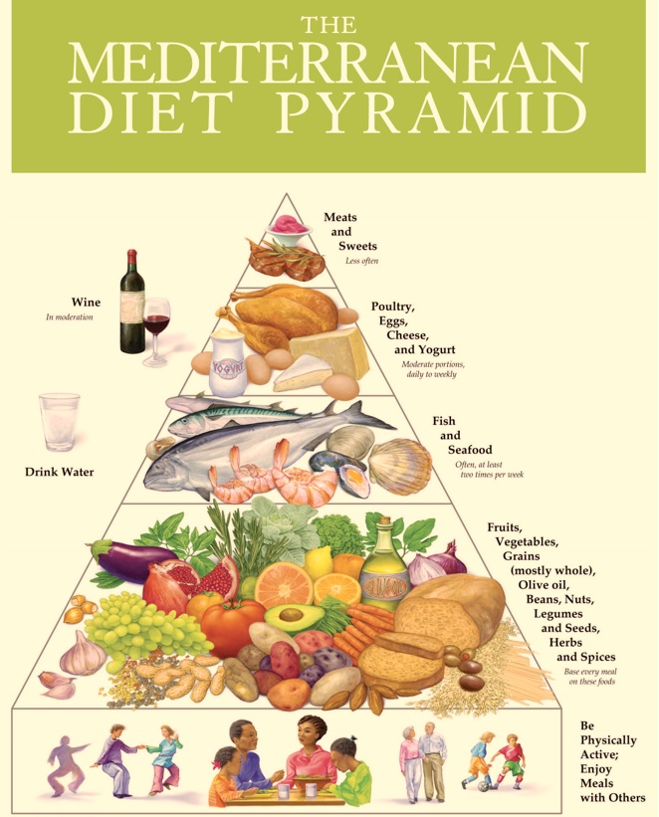

Α. …………..………………………………………………………………………………………………………………
……………..………………………………………………………………………………………………………………..
……………..………………………………………………………………………………………………………………..
……………..………………………………………………………………………………………………………………..
……………..………………………………………………………………………………………………………………..
……………..………………………………………………………………………………………………………………..
……………..………………………………………………………………………………………………………………..
Β. The table below shows the various meals that one consumes during the day. Suggest alternatives to those foods that you think are not the right food choices, according to the Mediterranean Diet pyramid.

Meals | Foods | Alternative dietary choices
Breakfast | → A glass of freshly squeezed orange juice  → A sausage roll
Morning snack | → A chocolate croissant
Lunch | → Burger with fries  → A glass of coca - cola
Afternoon snack | → 2 green apples
Dinner | → 3 pieces of special pizza  → A Greek salad (tomato, cucumber, peppers, olives and feta cheese)

C. If one chooses to eat this kind of food often in his/her weekly diet, what do you think will happen? Justify your answer.
……………..………………………………………………………………………………………………………………..
……………..………………………………………………………………………………………………………………..
……………..………………………………………………………………………………………………………………..
D. You decide as a team, to take part in a competition under the topic: ΄΄Healthy and economical snacks΄΄. You need to create a snack with high nutritional value, delicious and at the same time economical. Describe the ingredients you will use, the method and the cost of preparation, etc.
……………..………………………………………………………………………………………………………………..
……………..………………………………………………………………………………………………………………..
……………..………………………………………………………………………………………………………………..
……………..………………………………………………………………………………………………………………..
……………..………………………………………………………………………………………………………………..

