Title : Cell division & Powers

## 1st Teaching period

1st Activity



(a) (b) (c)

**Picture 1.** Each of us, like these other large multicellular organisms, begins life as a fertilized egg. After trillions of cell divisions, each of us develops into a complex, multicellular organism.

(Credit a: modification of work by Frank Wouters; credit b: modification of work by Ken Cole, USGS; credit c: modification of work by Martin Pettitt)

License: by OpenStax is licensed under Creative Commons Attribution License v4.0

This OpenStax book is available for free at <http://cnx.org/content/col11487/1.9>

Time: 10' min

Type of activity: Warm up, keeping notes and discussion on the content of the picture and reasoning about it.

Class organisation: In pairs, in small groups and in whole class.

**Actions/Tasks:** For a warm up teacher gives to the students a worksheet (Worksheet 1.1) with questions on the content of the picture. The students work in pairs or in small groups reading and keeping notes. In plenary they discuss on the content of the picture.

The aim of the activity is to introduce the students into the idea that the ability to reproduce is a basic characteristic of all living things. They may attribute that the offspring of any organism closely resembles its parent or parents. They can discuss about the hippopotamuses give birth to hippopotamus calves, monterey pine trees produce seeds from which Monterey pine seedlings emerge, and adult flamingos lay eggs that hatch into flamingo chicks. They may attribute that the offspring does not generally resemble exactly the parents.

2nd Activity



**Figure 2**

A sea urchin begins life as a single cell that (a) divides to form two cells, visible by scanning electron microscopy. After four rounds of cell division, (b) there are 16 cells, as seen in this SEM image. After many rounds of cell division, the individual develops into a complex, multicellular organism, as seen in this (c) mature sea urchin.

(credit a: modification of work by Evelyn Spiegel, Louisa Howard; credit b: modification of work by Evelyn Spiegel, Louisa Howard; credit c: modification of work by Marco Busdraghi; scale-bar data from Matt Russell).

License: by OpenStax is licensed under Creative Commons Attribution License v4.0

This OpenStax book is available for free at <http://cnx.org/content/col11487/1.9>

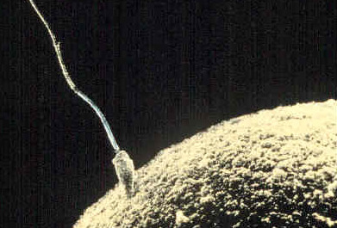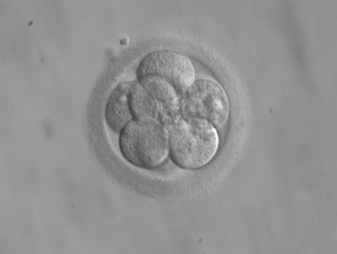

**Figure 3 Figure 4**

A sperm cell fertilizing an egg cell (ovum). Eight-cell embryo, at three days From Wikipedia, the free encyclopaedia.

Time: 10΄min

Type of activity: Reading comprehension, keeping notes and discussion on the content of the picture.

Class organisation: In pairs / in small groups and in whole class.

**Actions/Tasks:** The teacher gives to the students a worksheet (Worksheet 1.2) with questions on the content of the pictures.

The students work in pairs or in small groups reading and keeping notes. In plenary they discuss on the content of pictures.

The aim of the activity is to provoke a discussion about that many single-celled organisms and a few multicellular organisms can produce genetically identical clones of themselves through cell division, many single-celled organisms and most multicellular organisms reproduce regularly using another method called sexual reproduction. In this method parents produces haploid cells called gametes, which are the ovum for female and the sperm for the male.

The fusion of a haploid cell from each parent to form a single, unique diploid cell called zygote. In multicellular organisms, the new diploid cell will then undergo cell divisions to develop into an adult organism.

3nd Activity

Time: 25΄min

**Type of activity:** Watching the video, keeping notes and discussion on the content of the video and answer the worksheet.

**Class organisation:** In pairs / in small groups and in whole class.

**Actions/Tasks:** The teacher gives to the students a worksheet (Worksheet 1.3) with questions on the content of the video:

<https://www.youtube.com/watch?v=J99mZSQtOms> until 2.43΄min.

The students work in pairs or in small groups while watching the video and they are keeping notes. In plenary they discuss on the content of the video and answer the worksheet.

The aim of the activity is to learn the stages of the embryo, on the first week of pregnancy.

**Homework:**

1. The students asked to make a sketch of the multiple divisions of a human cell until sixteen new cells. Use the space below to draw four cell divisions your own way.

You may also use an online program, like sketchtoy.com to draw and share your image.

1. The students asked to answer a quiz in made in h5p.

## 2nd Teaching period

1st Activity

Time 25’ min

**Type of activity:** The class will work on a worksheet given by the teacher.

**Class organisation:** In pairs / in small groups and in whole class.

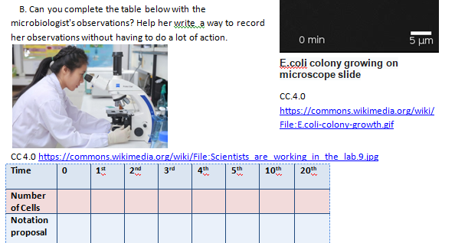**Actions/Tasks:** The teacher gives the students a worksheet ( work sheet 2.1) on a fictional story about the division of a cell of a unicellular organism and asks them to answer to the question in pairs/groups. She/he moves around in the classroom and gives help to the working groups. After 10-15’ min she/he asks students to announce in plenary the answers of the worksheet and suggest a way to write the number of cells at each step of cell division. The 1st aim is to introduce students to the necessity of using exponents in order to write the number of cells at each step of cell division. At this point she/he gives the definition of the notion of expontents. Alternatively, instead of giving the definition, she/he could show the students a video from [khan academy](https://www.khanacademy.org/math/cc-sixth-grade-math/cc-6th-arithmetic-operations/cc-6th-exponents/v/introduction-to-exponents) for exponents. The 2nd aim is to make students aware of the nonproportional nature of exponentials.

2nd Activity

Time 5’ min

**Type of activity:** The class will work on a worksheet given by the teacher.

**Class organisation:** In pairs / in small groups and in whole class.

**Actions/Tasks:** The teacher gives the students a worksheet ( Worksheet 2.2) in order to understand the difference between the mathematical operations multiplication and exponentiation.

3nd Activity

Time 5’ min

**Type of activity:** The class will work on a worksheet given by the teacher.

**Class organisation:** In pairs / in small groups and in whole class.

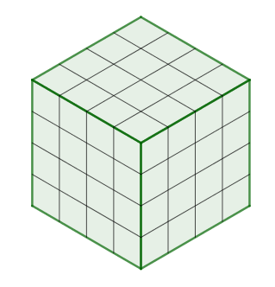

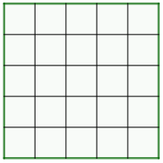**Actions/Tasks:** The teacher gives the students a worksheet ( Worksheet 2.3) in order to understand the terminology “*square of…” and “cube of ..”*

4th Activity

Time 10’ min

**Type of activity:** The class will work on a worksheet given by the teacher.

**Class organisation:** In pairs / in small groups and in whole class.

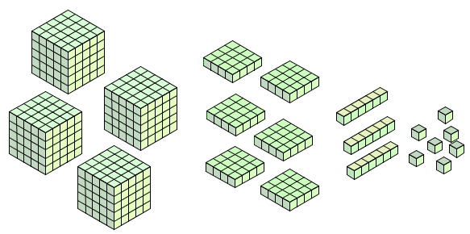

**Actions/Tasks:** The teacher gives the students a worksheet ( Worksheet 2.4 ) about the order of operations in a mathematical expression that contains exponentials. The aim of the activity is students make a conjecture about the right order of operation.

Home work

1. For homework the teacher among others could give the following links for practice.
2. <https://www.khanacademy.org/math/cc-sixth-grade-math/cc-6th-arithmetic-operations/cc-6th-exponents/e/positive_and_zero_exponents>
3. <https://www.khanacademy.org/math/cc-sixth-grade-math/cc-6th-arithmetic-operations/cc-6th-order-of-operations/e/order_of_operations_2>

All Khan Academy content is available for free at [www.khanacademy.org](https://www.khanacademy.org/)” and adhere to the [Khan Academy brand guidelines](https://support.khanacademy.org/hc/en-us/articles/202263034-What-is-Khan-Academy-s-Trademark-and-Brand-Usage-Policy-).

## 

1. The students asked to create a word cloud art in <https://wordart.com/> with words learned at the previous two teaching periods.

