**1st Teaching Period**

**Worksheet 1.1**

**1st Activity**



(a) (b) (c)

**Picture 1.** Each of us, like these other large multicellular organisms, begins life as a fertilized egg. After trillions of cell divisions, each of us develops into a complex, multicellular organism.

(credit a: modification of work by Frank Wouters; credit b: modification of work by Ken Cole, USGS; credit c: modification of work by Martin Pettitt)

License: by OpenStax is licensed under Creative Commons Attribution License v4.0

This OpenStax book is available for free at <http://cnx.org/content/col11487/1.9>

**Chapter Outline**

The ability to reproduce *in kind*is a basic characteristic of all living things. *In kind* means that the offspring of any organism closely resembles its parent or parents. Hippopotamuses give birth to hippopotamus calves; Monterey pine trees produce seeds from which Monterey pine seedlings emerge; and adult flamingos lay eggs that hatch into flamingo chicks. *In kind* does not generally mean *exactly the same*. While many single-celled organisms and a few multicellular organisms can produce genetically identical clones of themselves through mitotic cell division, many single-celled organisms and most multicellular organisms reproduce regularly using another method.

Note that, in genetics, "parent" is often used to describe the individual organism(s) that contribute genetic material to an offspring, usually in the form of gamete cells. The concept of a genetic parent is distinct from social and legal concepts of parenthood, and may differ from those whom people consider their parents. Even within the animal kingdom, characteristics that may often be associated with sexual reproduction, such as parental care or sexual behavior, are not universal.

Sexual reproduction is the production of haploid cells and the fusion of a haploid cell from each genetic parent to form a single, unique diploid cell. In multicellular organisms, the new diploid cell will then undergo mitotic cell divisions to develop into an adult organism. A type of cell division called meiosis leads to the haploid cells that are part of the sexual reproductive cycle. Sexual reproduction, specifically meiosis and fertilization, introduces variation into offspring that may account for the evolutionary success of sexual reproduction. The vast majority of eukaryotic organisms can or must employ some form of meiosis and fertilization to reproduce.

<https://openstax.org/books/concepts-biology/pages/7-introduction>

After you read carefully the above text, then you should answer the following questions:

1. Which kind of biological function, that all living organisms have, describes the above photo?

………………………………………………………………………………………………………………………..

1. What babies the hippopotamuses give birth to?

………………………………………………………………………………………………………………………..

1. How the Monterey pine trees are reproducing?

………………………………………………………………………………………………………………………..………………………………………………………………………………………………………………………..

1. How the adult flamingos produce flamingo chicks?

………………………………………………………………………………………………………………………..

1. Are the offspring of these organisms closely resembling its parent?

………………………………………………………………………………………………………………………..

**Worksheet 1.2:**

**2nd Activity:**



**Figure 2.** A sea urchin begins life as a single cell that (a) divides to form two cells, visible by scanning electron microscopy. After four rounds of cell division, (b) there are 16 cells, as seen in this SEM image. After many rounds of cell division, the individual develops into a complex, multicellular organism, as seen in this (c) mature sea urchin.

(credit a: modification of work by Evelyn Spiegel, Louisa Howard; credit b: modification of work by Evelyn Spiegel, Louisa Howard; credit c: modification of work by Marco Busdraghi; scale-bar data from Matt Russell).

License: by OpenStax is licensed under Creative Commons Attribution License v4.0

This OpenStax book is available for free at <http://cnx.org/content/col11487/1.9>

After you read carefully the explanation text of figure 2, then answer the following questions:

1. How a sea urchin begins life?

………………………………………………………………………………………………………………………

1. Through which procedure does a sea urchin produce itself?

………………………………………………………………………………………………………………………

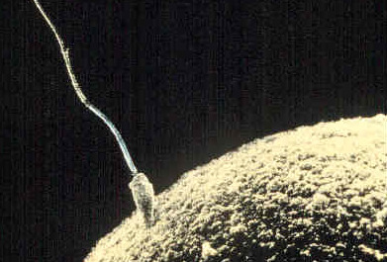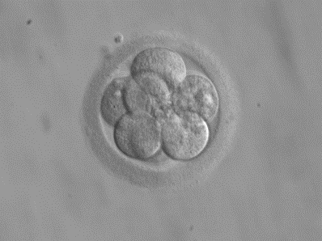

**Figure 3 Figure 4**

Fertilization is the process in which sperm and egg fuse to form a zygote. (credit: scale-bar data from Matt Russell)

A sperm cell fertilizing an egg cell (ovum). Eight-cell embryo, at three days.

From Wikipedia, the free encyclopaedia.

Reading the following text:

The individual sexually reproducing organism—including humans—begins life as a fertilized egg, or zygote. Trillions of cell divisions subsequently occur in a controlled manner to produce a complex, multicellular human. In other words, that original single cell was the ancestor of every other cell in the body. Once a human individual is fully grown, cell reproduction is still necessary to repair or regenerate tissues. For example, new blood and skin cells are constantly being produced. All multicellular organisms use cell division for growth, and in most cases, the maintenance and repair of cells and tissues. Single-celled organisms use cell division as their method of reproduction.

<https://openstax.org/books/concepts-biology/pages/6-introduction>

After you read carefully the above text, then you should answer the following questions:

1. What is the name of the original single cell, that is the ancestor of every other cell in our body?

………………………………………………………………………………………………………………….

1. How many cell divisions occur in order to produce a complex multicellular human?

…………………………………………………………………………………………………………………

1. What is the name of the procedure, which describes cell reproduction?

…………………………………………………………………………………………………………………

1. In figure 3, what is the name of these cells in general and in particular?

………………………………………………………………………………………………………………….

1. How many cells can you count, in figure 4?

………………………………………………………………………………………………………………….

1. A multicellular organism uses cell division for what for?

………………………………………………………………………………………………………………….

1. A single cell organism uses cell division for what for?

………………………………………………………………………………………………………………….

**Worksheet 1.3**

**3rd Activity:**

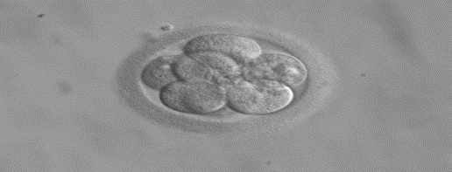

<https://en.wikipedia.org/wiki/Image:Embryo%2C_8_cells.jpg>

**Human embryo under microscope: This is how life begins at conception.**

After watching the following video until 2.43΄ min, then you should be able to answer the worksheet below:

<https://www.youtube.com/watch?v=J99mZSQtOms&t=120s&ab_channel=SaraQureshi>

1. What is the name of the first cell which results after the sperm fertilizes the ovum?

……………………………………………………………………………………………………………………………………

2. What happens after sixteen hours to the fertilized egg?

……………………………………………………………………………………………………………………………………

3. What happens after 24 hours to the fertilized egg?

……………………………………………………………………………………………………………………………………

4. In how many hours the embryo reaches the four-cell stage?

……………………………………………………………………………………………………………………………………

5. In how many days the embryo reaches the eight-cell stage?

……………………………………………………………………………………………………………………………………

6. In how many days the embryo reaches the sixteen-cell stage?

……………………………………………………………………………………………………………………………………

7. In how many days the embryo reaches the thirty-two-cell stage?

……………………………………………………………………………………………………………………………………

8. What happens to the fertilized egg in the first week of pregnancy?

…………………………………………………………………………………………………………………………………………

**2nd Teaching Period**

**1st Activity (Worksheet 2.1 )**

The cells of a unicellular organism divide every hour. The microbiologist in a laboratory managed to isolate one of the cells of this organism and observes it with her microscope at regular intervals. Records the number of cells in a table.

A. Can you estimate how many cells the microbiologist will count

A. after 5 hours?

B. after 10 hours?

B. Can you complete the table below with the microbiologist's observations? Help her write a way to record her observations without having to do a lot of action.

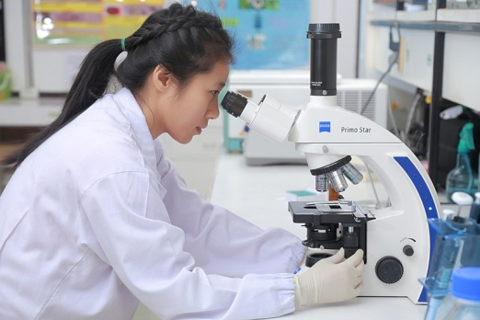

E.coli colony growing on microscope slide

CC.4.0 <https://commons.wikimedia.org/wiki/File:E.coli-colony-growth.gif>

CC 4.0 <https://commons.wikimedia.org/wiki/File:Scientists_are_working_in_the_lab.9.jpg>

|  |  |  |  |  |  |  |  |  |
| --- | --- | --- | --- | --- | --- | --- | --- | --- |
| **Time** | **0** | **1st** | **2nd** | **3rd** | **4th** | **5th** | **10th** | **20th** |
| **Number of Cells** |  |  |  |  |  |  |  |  |
| **Notation proposal** |  |  |  |  |  |  |  |  |

**2nd Activity (Worksheet 2.2)**

Do the following calculations. What are the similarities and what are their differences?

Α. $2+2+2+2=$

Β. $2⋅4=$

C. $2⋅2⋅2⋅2=$

D. $2^{4}=$

**3nd Activity (Worksheet 2.3)**

1. Write the number of small squares that make up the big square using exponentials.
2. The exponential $5^{2}$ is called five squared. Can you imagine why?



1. Write the number of small cubes that make up the big cube using exponentials.
2. The exponential $4^{3}$ is called 4 cubed. Can you imagine why?

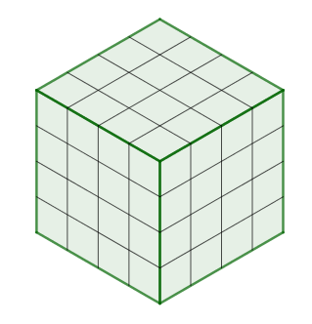

**4th Activity (Worksheet 2.4)**

Jasmine claims that the number of the small cubes at the picture is the value of the following numerical expression $4⋅5^{3}+6⋅4^{2}+3⋅5+6$. Do you agree with Jasmine ? Try to evaluate the numerical expression.

Try to make a rule about the order of operations when we want to evaluate a math expression .

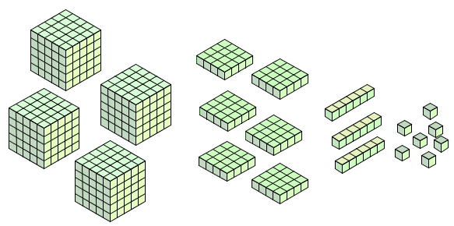

***Theory***

* *The product $\overset{n-times}{\overbrace{a∙a∙a⋯a}}$ symbolised as αn, consists of n factors and pronounced power with base a and exponent n, n>1.*

e.g.  **4 is the exponent**

**2∙2∙2∙2 = 24**



4 factors **2 is the base**

*We read power with base 2 and exponent 4 and by this we mean the multiplication* ***2∙2∙2∙2 = 16.***

* *For n=0 we define* ***a0=1****, a≠0.*
* *For n=1 ορίζουμε* ***α1=α***
* *The power αn pronounced n-th power of a*
* *The power α2 pronounced a squared*
* *The power α3  pronounced a cubed.*
* *In a numerical expression the powers precede the other operations*

*e.g. $3⋅2^{4}+5=3⋅16+5=48+5=53.$*

**Home work**

1. Follow the link and answer the questions
2. <https://www.khanacademy.org/math/cc-sixth-grade-math/cc-6th-arithmetic-operations/cc-6th-exponents/e/positive_and_zero_exponents>
3. <https://www.khanacademy.org/math/cc-sixth-grade-math/cc-6th-arithmetic-operations/cc-6th-order-of-operations/e/order_of_operations_2>
4. Follow the link <https://wordart.com/> and make word cloud art using the words of the notions that you learned at the previous 2 teaching periods.