## Speed of Sound - Worksheet2

### **1st Activity**

On the LCD screen the value of the obstacle's distance S is missing. In order to manage to program the arduino board to appear on the LCD screen the distance S, do the following activities.

1. Find the **average value of sound’s speed** using the values from the previous experiment.
2. Can you construct a formula in order to be able to calculate the distance of the obstacle, if you know the total travelling time of sound?

C. Use your formula to calculate the distance S (between the sensor and the obstacle), if the sound’s total travelling time is equal to 0,1msec.

### 

### **2nd Activity**

To perform the activity’s experiment follow the link [*https://www.tinkercad.com/things/fdZ7OsE9K74*](https://www.tinkercad.com/things/fdZ7OsE9K74), click “**Tinker This**” and then click “**Start Simulation**” to simulate the circuit.

Press the **SIMULATION** button to run the code.

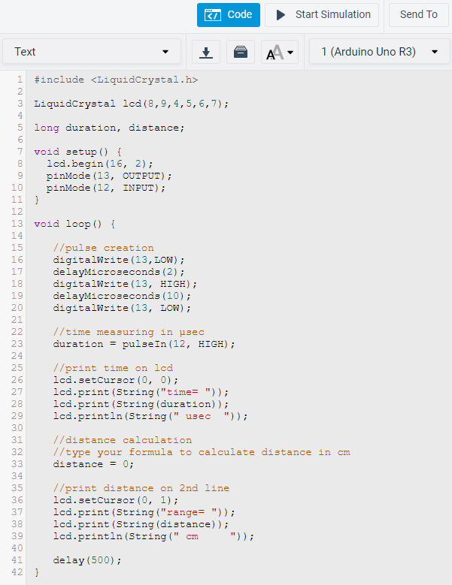

Click on the ultrasonic sensor and move the blue dot (obstacle).

*The distance is always zero, because you have to construct the right formula at the 33th line of the code.*

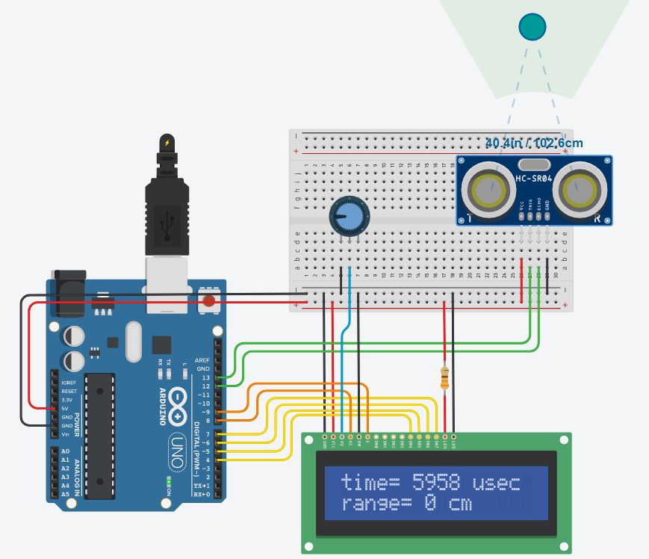

Compare your result (distance in cm) displayed on the LCD with the corresponding one from the simulation. Is it the same?

If you are using a real ultrasonic sensor, use a ruler to measure the actual distance.