The Women behind Maths

Worksheet 1

Preparation

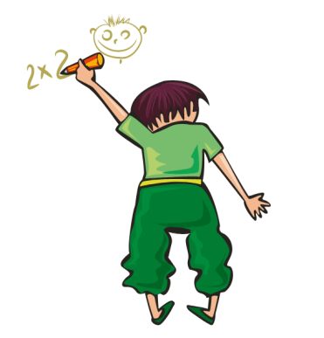Watch the presentation that your teacher shows you!

Can you think of three people that are important in the field of mathematics?

**If this question seems a little difficult, you can search the internet, your books or even ask people you know**.

Then, use this [link](https://www.menti.com/diewfsr6bd) or scan the QR code to write the **three names**!

You should also **write a small text** (2-3 sentences) to explain why this person is important for the mathematical science and bring it with you in the next lesson!

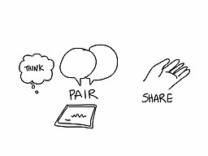

1st Teaching period

Activity 1

Look at the word cloud that is formed by your answers:

(<https://www.mentimeter.com/app/presentation/80970ed38848356871a030a91c6413e6/70ab6a664cb5>)

1. Think for 1’

**Look at the word- Cloud! What do you Notice ?**

1. Share your ideas with your partner for 2’
2. Discuss it with your classmates!

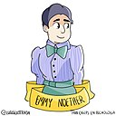Activity 2

Read the article about [Emmy Noether](https://theconversation.com/emmy-noether-faced-sexism-and-nazism-100-years-later-her-contributions-to-ring-theory-still-influence-modern-math-163245) and fill in the table. You can refer to the [quizlet](https://quizlet.com/_bruhi5?x=1jqt&i=15er9s) glossary if you want!

|  |  |
| --- | --- |
| **Full name:** |  |
| **Nationality:** |  |
| **Date of birth:** |  |
| **Major achievements:** |  |
| **Major obstacles:** |  |
| **Factors that helped her succeed (external or internal):** |  |
| **Died in:** |  |

Is there any information still missing? Search the web or ask your teacher for help!

Activity 3

Now, that we have all the relevant information, let’s make a flipbook about **Emmy Noether**! Your teacher is going to show you how!

Homework

**You are going to be divided into groups in order to study the life and works of two other famous mathematicians, from different periods of time. According to the group that you belong, you should visit the sites provided, or any other site you can find. First, fill in the table with the relevant information and then create a flipbook about this mathematician using** [**storyjumper**](https://www.storyjumper.com/)**! Alternatively you can draw your own poster, placing the relevant information on it!**

|  |  |
| --- | --- |
| Hypatia | Karen Uhlenbeck |
| * <https://www.worldhistory.org/video/2639/hypatia-of-alexandria-the-female-mathematician-ast/> * <https://open.spotify.com/episode/3RtNfprdYwHmaxYnCzli8y?si=7FBYa7HrQWOw3WZaM9NrrA> | * <https://www.symmetrymagazine.org/article/crossing-fields-karen-uhlenbeck> * <https://en.wikipedia.org/wiki/Karen_Uhlenbeck> * <https://en.wikipedia.org/wiki/Karen_Uhlenbeck> |

|  |  |
| --- | --- |
| **Full name:** |  |
| **Nationality:** |  |
| **Date of birth:** |  |
| **Major achievements:** |  |
| **Major obstacles:** |  |
| **Factors that helped her succeed (external or internal):** |  |
| **Died in:** |  |