The Women behind Maths

Worksheet 2

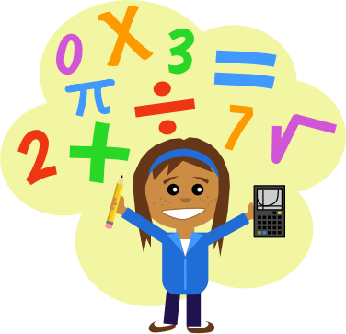2nd Teaching period

Activity 1

Watch the other groups’ presentations!

Activity 2

These 3 women (Emmy Noether, Hypatia and Karen Uhlenbeck) lived in different historical periods, and could all be characterized as positive role models. What is the one thing that has impressed you most or what is the one thing that you have learnt by them? (Write it anonymously on a piece of paper and put it in the box).

Activity 3

**There is a strong gender imbalance in higher mathematics education and in mathematics as a professional field in several European countries. Other science areas and technology show similar patterns of gender imbalance.**

1. Which factors can **encourage** a woman’s occupation with mathematics (+) and which factors can **discourage** it (-)? Fill in the lists:

|  |  |
| --- | --- |
| + | − |
|  |  |
|  |  |
|  |  |
|  |  |
|  |  |

1. Now look at the following questions. In your groups, decide if they are suitable for a questionnaire to be distributed to people from other classes in the school to investigate what their opinion is on the topic **“Gender and Mathematics”.**

1. Girls avoid working professionally in "traditional" male occupations.

a) I strongly disagree b) I disagree c) I neither agree nor disagree d) I agree e) I strongly agree

2. The stereotypical view that mathematics is a domain primarily for men is of paramount importance in the development of a child's confidence in his mathematical abilities.

a) I strongly disagree b) I disagree c) I neither agree nor disagree d) I agree e) I strongly agree

3. Particularly in western countries, boys are more likely than girls to believe that mathematics is a study more suited to males (male domain), and generally believe that they are better at mathematics than girls.

a) I strongly disagree b) I disagree c) I neither agree nor disagree d) I agree e) I strongly agree

C) Can you think of any other questions that could be included in the questionnaire?

_____________________________________________________________________________________________________________________________________________________________________________________________________________________________________________________________________________________________________________________________________________________________________________________________________________________________________________________________________________________________________________________________________________

D) Now use **google forms** to create your questionnaire. Ask as many students you know to fill it in, so that the results will be more accurate. In the next lesson, we are going to discuss the results!

Activity 4

***Increasing girls’ participation in mathematics requires moving beyond current efforts to raise female interest and confidence to disrupt enduring discourses of male superiority in mathematics.***

* What does this phrase mean?
* How can you explain the purpose of the research to your classmates, who will answer the questionnaire, so that their answers will be more accurate?