**AESTHETIC VALUE AND INFORMATION ON FOOD PACKAGING** 

https://youtu.be/42PU19EUMDA

**The aesthetic value of food** is covers two important issues: • aesthetics of the products as such;

• aesthetics of the packaging.

**The aesthetic appearance** of the product represents a important factor in shaping the first impression of to the consumer in relation to the product. Aesthetic message, attractive, it can be transmitted to the buyer in a manner directly by the product through its aesthetic elements, and namely: color, shape, way of decoration, structure 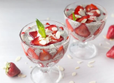

and the harmony of the product.

**Packaging design** plays an important role in the valorization of food products. Packaging must ensure a positive visual impact, thus so that it can be easily noticed, thanks to illustrations

graphic or brand.

The aesthetics of the product refers to its pleasant shape, the attractive color, the ornamentation, the way of presentation. The color of the processed food products must be harmonized with the aroma (taste and smell), this being a criterion for assortment differentiation of products from the same raw material. 

For packaging, the elements that give the aesthetic value are: the shape of the packaging, the color, the graphics, the materials used for manufacturing. On the packaging itself, vignettes, labels, bands are applied, which increase the aesthetic value of the packaging

Quality food must be: 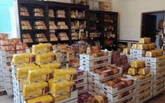

obtained from quality raw materials, as natural as possible;

economic;

obtained using appropriate preparation techniques;

presented as attractively as possible.

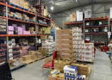

**The packaging of a product has the following roles:**

**- provides identification-information data;**

**- contributes to the education and development of taste for beauty through form, color, text; - it has a protective role and maintains the quality of the product;**

**- facilitates the handling of the product.**

**The packaging can be made of: plastic, wood, textiles, glass, paper, metal.**

**Information appearing on the packages and labels:**

**A. product identifiers:**

**- name and brand name of the product. Marking is the quality factor with a double role: aesthetic and information and identification of the product;** 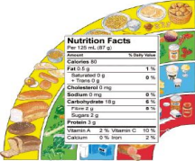

**- manufacturing company;**

**- net quantity;**

**- recyclable packaging;** 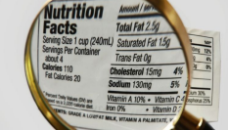

**B. product information:** 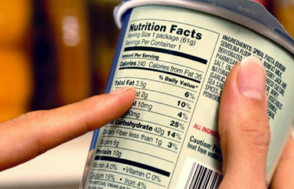

– date of manufacture and shelf life – for food is the time limit/date set by the manufacturer until which a product retains its original specific characteristics, if the conditions of transport, handling, storage and storage have been observed;

- Barcode – consists of several vertical lines under which there are figures that signify: the country of origin, the manufacturer, the name of the product and its control figure;

- contact the producing company; - ingredients; 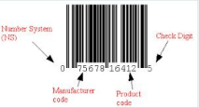

- storage conditions,

- energy value (kcal);

- nutritional value (nutritional declaration).

**Anti-pollution packaging**

Packaging made of anti-pollution materials meets a number of criteria:

- minimal consumption of material;

- the possibility of recycling the packaging, after use;

- the absence of harmful substances through the destruction of the material.

The symbols used for labeling ecological products are:

- The European Union Ecolabel, created by the European Commission in 1992, is a unique certification scheme to help consumers distinguish 'green' products and services that do not harm the environment.

The 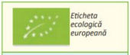

european

eco-label

– The national 'ae' logo, specific to organic products, together with the Community logo, is used to complete the labelling, in order for consumers to identify products obtained in accordance with organic

production methods.

**The abbreviation for national ”ae”, specific for organic products**

The bar code consisting of parallel vertical lines with numbers below has the following meaning:

- first two or three digits - country of origin;

- the next five consecutive digits - the manufacturer's name; - the next five other digits - product name;

- the last digit - the control number of the code.

The labeling of ecological products according to the regulations in force requires that the label contain: 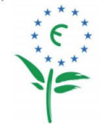

- the name and address of the manufacturer;

- name of the product, including the organic production method;

- the name and brand of the inspection and certification body - the National Organic Products Authority (ANPE);

- storage conditions;

- the minimum period of validity;

- ecological logo. In the EU, for eco products, a unique brand 'European Flower' is used. The European Flower refers to the product's impact on the environment (recyclable packaging, biodegradable and long-lasting products).

**For the protection of consumers and the environment, different symbols are written on ecological packaging:**

certified quantity - it is passed next to the nominal weight; container made of non-toxic material; 

according to European criteria; recyclable packaging; 

**Mobius loop Mark the green dot**

recyclable plastic packaging; 

product from organic agriculture; 

ecologically obtained agricultural products according to the EU Regulation; 

**The symbol for**

**separate recycling**

**indicates that this**

**type of waste is**

**collected separately**

The control and certification of organic products are ensured by inspection and certification bodies: 

THANK YOU!!!