**WORKSHEET 1C**: ‘**The historians’** **(*Byron’s Philhellenism*)**

Study from the online resources given below the relevant material about Lord Byron’s Philhellenism.

* What impact did the Greek War of Independence have on Byron’s a) views, and b) actions?
* Choose the most important facts about Byron’s life and death that prove his Philhellenism
* Discuss with your group
* Explain why Lord Byron had such a great impact on the issue of Philhellenism in Europe
* Explore the ways in which Lord Byron’s contribution to the Greek War of Independence was represented in art (paintings).

Online resources

* <https://www.europeana.eu/el/item/2051939/data_euscreenXL_EUS_17BC905C0656F851AAA0048CF32BC97C> (Byron and Greece)
* <https://lordbyron.org/archives.php?choose=MissolonghiMem>
* <https://phmus.org/en/lord-byron/>
* <https://wiki.kidzsearch.com/wiki/Lord_Byron>
* <https://www.lordbyron.org/>
* <https://www.messolonghibyronsociety.gr/timeline-gr/>
* <https://en.wikipedia.org/wiki/Timeline_of_Lord_Byron>
* <https://www.britannica.com/biography/Lord-Byron-poet>

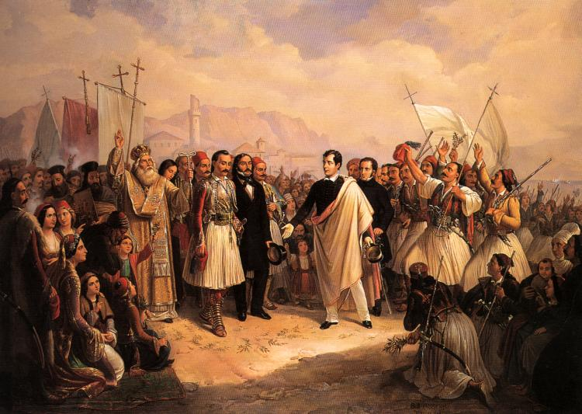

[The Reception of Lord Byron at Missolonghi](https://commons.wikimedia.org/wiki/File:Lord_Byron_at_Missolonghi.jpg) by Theodoros Vryzakis, is licensed under [Public domain](https://en.wikipedia.org/wiki/Public_domain), via [Wikimedia Commons](https://commons.wikimedia.org/)