**WORKSHEET 2A*: Lord Byron, a Romantic poet.***

* Study the relevant material from the online resources given below and fill in the TABLE that follows.

|  |  |
| --- | --- |
| **Main features of Romanticism**  **in poetry** | **Byron’s particular characteristics as a Romantic poet** |
|  |  |

Online Resources

* <https://en.wikipedia.org/wiki/Childe_Harold%27s_Pilgrimage>
* <https://www.britannica.com/art/Romanticism>
* <https://www.oercommons.org/courses/an-exploration-of-romanticism-through-art-and-poetry>
* <https://en.wikipedia.org/wiki/Byronic_hero>
* <https://en.wikipedia.org/wiki/Lord_Byron>

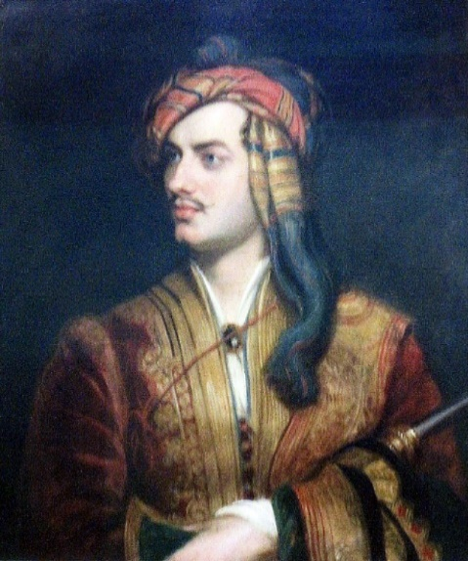

[Lord Byron, poet, by Thomas Phillips, National Portrait Gallery, London](https://www.flickr.com/photos/calotype46/14088090668) by [Snapshooter46](https://www.flickr.com/photos/calotype46/), is licensed under [CC-BY-NC-SA](https://creativecommons.org/licenses/by-nc-sa/2.0/) via [Flickr](https://www.flickr.com/)