Work Sheet 1

Student name:

*1st Teaching Period*

1st Activity

Observe carefully the vehicle and try to identify and name as many of its parts as you can. Note the name of each part you can recognise in the pictures below

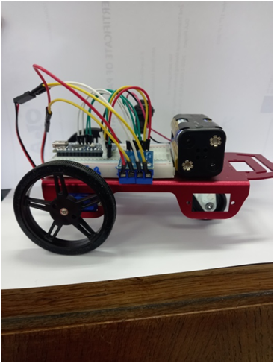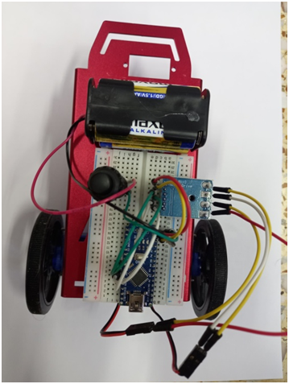

|  |
| --- |
| Vehicle parts: |
| 1. |
| 2. |
| 3. |
| 4. |
| 5. |
| 6. |
| 7. |
| 8. |
| 9. |
| 10. |
|  |
|  |

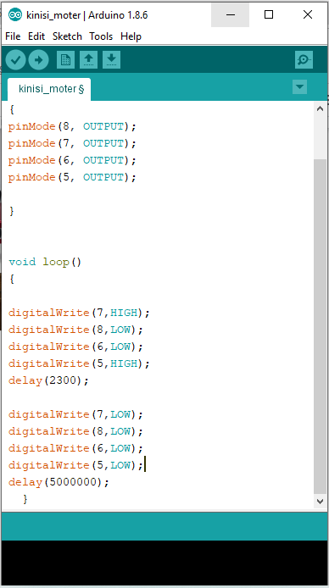2nd Activity

In the adjacent image you can see the necessary code to control the vehicle to move forward and backwards.

The code is controlling the two motors of the vehicle.

The code is uploaded to the Arduino UNO by a usb cable pressing the the arrow .

The command delay()  determines the time that the motors will work.

The value in the brackets (2300) is the delay time measured in milliseconds.

**Questions**

1. How many seconds are 2300 milliseconds;

______ sec

1. Suppose that you want to make the vehicle move for 5 sec. What amendment should you make to the code?

Make the necessary changes, upload the code, press the start button and use a timer to check if you reached the desired outcome.

3rd Activity

Open the file Workdistribution.xlsx

Place your name according to the duties at the whole class level and in small groups.

<https://docs.google.com/spreadsheets/d/1DfAgO_OnLhNNMW4WTNkg05dOyMWXCTuntDQ8xY0rw1k/edit#gid=0>