Script: Old Materials, New Sounds

Title: Old Materials, New Sounds
Authors: Naiara Azpeitia & Naiara Allende

Collaborative subjects: MUSIC AND TECHNOLOGY

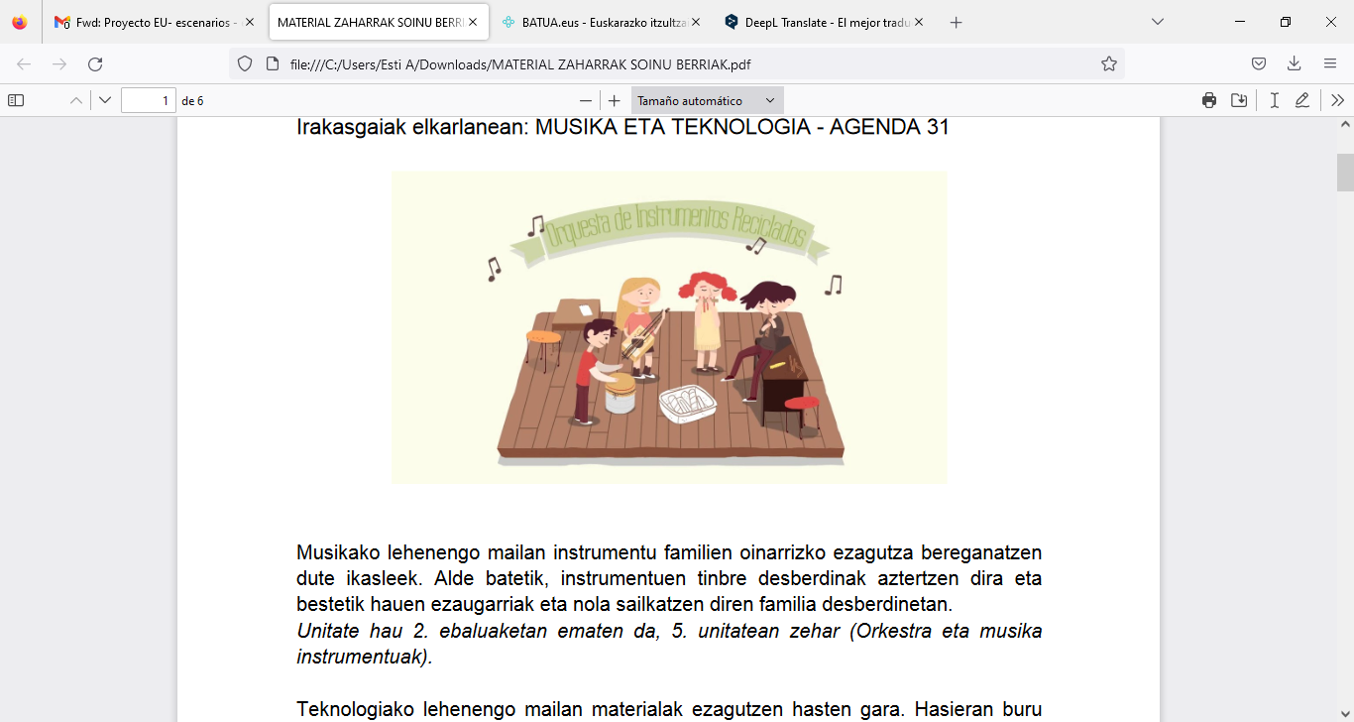

In the first year of Music, students acquire the basic knowledge of the instrument families. On the one hand, the instruments’ different timbres are analysed as well as their characteristics and how they are classified into different families.
This teaching unit is taught during the 2nd term, in the 5th unit (Orchestra and musical instruments).

In the first year of Technology, students start learning about materials. In the beginning, by means of a mind map, the most common materials are summarised. Then the concepts of wood, paper and plastic are analysed.

On the other hand, Agenda 31 is an education programme that promotes sustainability and quality within the school. It is based on community participation and involves and contributes to the sustainable development of the environment. As an environmental education programme, its main objective is to develop knowledge, skills, attitudes, motivation and commitment to participate in solving environmental problems.

The project called "Old Materials - New Sounds" is carried out in collaboration with Music and Technology, following the Agenda 31 programme.

Objectives

The project focuses on building a more sustainable environment, following the objectives of Agenda 31. In this sense, the aim is to prove that it is highly possible to create tools and objects for our daily life with materials that may be recycled. It is also possible to create tools that help to create works of art or art itself.
In this way, a step will be taken towards the integration of art at school, with students working on their artistic creativity.

Purpose:  To give a second life to materials that may be recycled by creating different musical instruments. | 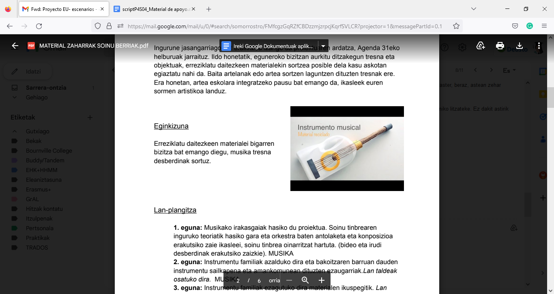

Workgroups  There will be groups of 4-6 students, without mixing those who speak different languages.  Each group should create one or two instruments (from the same family). All instrument families must be present in each class. | 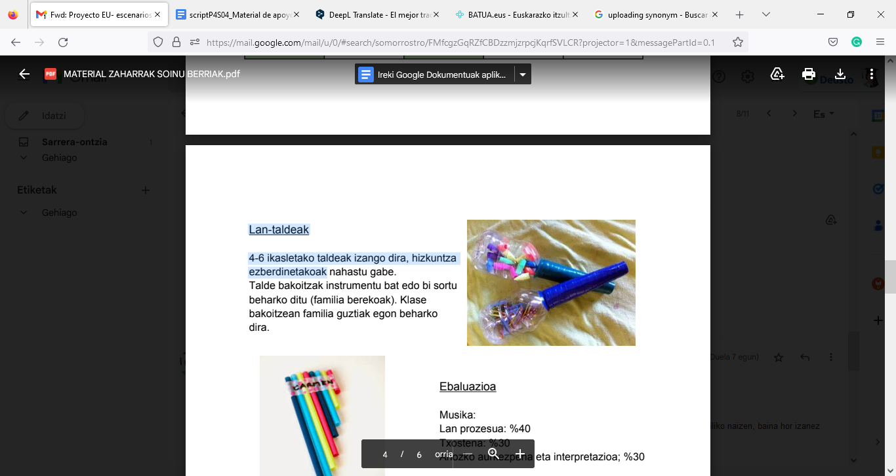
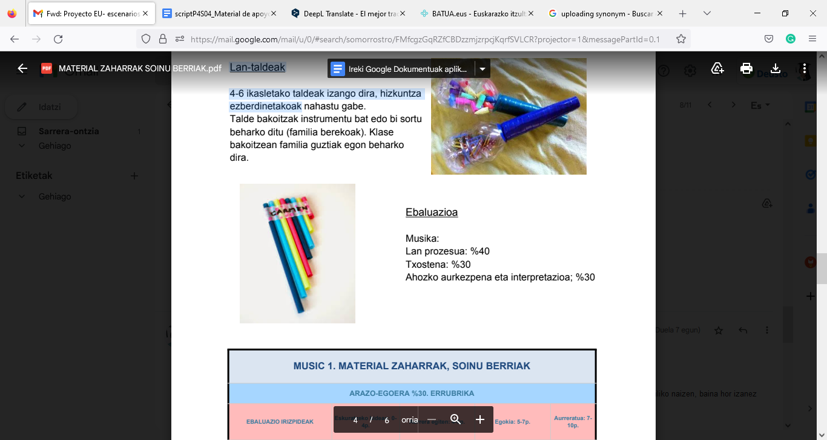 | Assessment  Music:  Work development: 40%  Report: 30%  Oral presentation and performance: 30%

MUSIC 1. OLD MATERIALS, NEW SOUNDS
SCENARIO 30%. RUBRIC
ASSESSMENT CRITERIA |  | Getting there:  0-4p | Making progress: 4-5p | Appropriate: 5-7p | Advanced:  7-10p
DEVELOPMENT OF WORK 40% | INTEREST AND CARE | The student HARDLY EVER shows any interest. (S)he has not brought any materials. | The student SOMETIMES shows interest. (S)he has not brought all the materials or has brought them late. | The student shows GREAT interest. (S)he has brought the materials. | The student works PERFECTLY. (S)he is careful and shows interest, makes interesting contributions and tries to solve problems.  (S)he has brought all the materials.
ORAL PRESENTATION AND PERFORMANCE 30% | FLUENCY AND INTERACTION | The student speaks slowly and makes too many pauses, has difficulties in communicating and expresses ideas BADLY and has not prepared any performance. | The student speaks quite fluently but makes pauses, understands questions and answers them appropriately. GOOD organisation during the speech. (S)he has prepared the performance a little. | The student follows the conversation appropriately, expresses things with remarkable fluency, answers questions and replies to opinions VERY WELL and makes very few pauses. The performance has been prepared. | Perfect speech. The student expresses ideas fluently, answers questions and replies to opinions OUTSTANDINGLY, and has made great efforts to prepare for the performance.
WRITTEN PRESENTATION:  REPORT  30% | CREATIVITY AND STRUCTURE | The final product is INSUFFICIENT and of poor quality. There are mistakes in it. The student has not taken any theory into account. | The final product is HALF-FINISHED but it is quite decent. Some points of the theory have been taken into account. | The final product is VERY GOOD and organised. The student has taken into account the learnt theory and has also included it. | The final product is EXCELLENT and very well-organised. The student has correlated the theory with the practical part.
 |  |  |  | IN TOTAL: | 10 POINTS

Assessment:
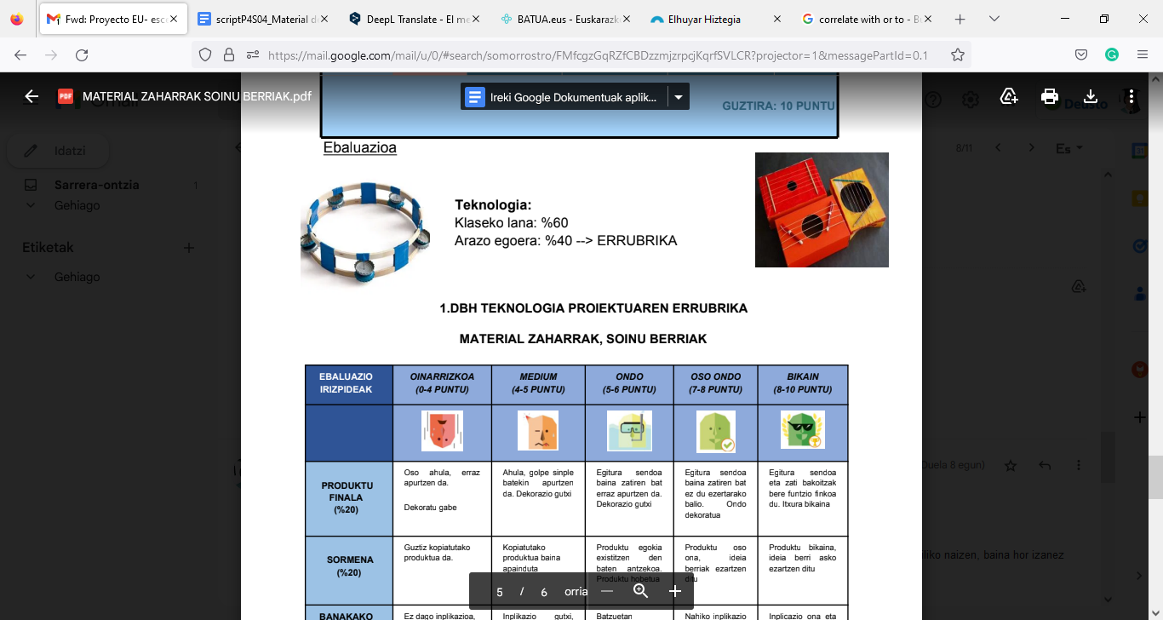 | Technology:  Classwork: 60%  Scenario: 40% -> Rubric
RUBRIC FOR THE TECHNOLOGY PROJECT IN THE FIRST YEAR OF SECONDARY SCHOOL OLD MATERIALS, NEW SOUNDS

ASSESSMENT CRITERIA | BASIC  (0-4 POINTS) | MEDIUM  (4-5 POINTS) | GOOD  (5-6 POINTS) | VERY GOOD  (7-8 POINTS) | EXCELLENT  (9-10 POINTS)
FINAL PRODUCT  (20%) | Very fragile, it breaks easily and is not decorated. | Fragile, it breaks with a simple blow and has too few decorations. | It has a hard structure but some parts may break easily and has too few decorations. | It has a hard structure but some parts are useless. It is very well-decorated. | It has a hard structure and each part has a fixed purpose. It looks perfect.
CREATIVITY  (20%) | The project has been copied entirely. | It is a copied product with slight modifications. | It is similar to an existing appropriate product, but it has been improved. | It is a very good product, it includes new, good ideas. | It is an excellent product, it includes many new, good ideas.
INDIVIDUAL WORK  (Involvement)  (20%) | Very little involvement in the organisation or planning. | Little involvement, insufficient organisation and planning. | Some involvement and organisation. | Quite a lot of involvement and organisation. | Great involvement and excellent organisation.
MATERIALS  (20%) | The student has not brought any materials. The used materials are not appropriate and (s)he has wasted a lot of materials. | The student has not brought all the materials or has brought them late. The used materials are not appropriate and (s) has wasted a few materials. | The student has brought almost all the materials and has used the appropriate ones. (S)he has wasted very few materials. | The student has brought the materials and has used recycled ones.  (S)he has not wasted any material. | The student has brought the materials and has used recycled materials that may be reused.  (S)he has not wasted any of the materials.
MEETING DEADLINES  (20%) | The deadline has not been met and there is still a long way to go before the final product is finished. | The deadline has not been met but the final product is not far from finished. | The deadline has been met but the final product is unfinished. | The deadline has been met but the final product is unfinished even if it is not far from finished. | The deadline has been met and the final product is finished.

1st Activity: The theory of sound timbre and organisation/composition of an orchestra

Type of activity: Explanation of theory
Class organisation: Whole class
Actions/Tasks: The project starts in Music (the subject). Students learn the theory of sound timbre and are shown the organisation and composition of an orchestra based on sound timbre (different videos and images will be shown).

2nd Activity: Instrument families (Part 1) and class organisation

Type of activity: Explanation of theory
Class organisation: Whole class
Actions/Tasks: The teacher explains the different instrument families, their classification and the common characteristics of each of them. Teams are formed to work in groups.

3rd Activity: Instrument families (Part 2), selection of instrument and group organisation

Type of activity: Explanation of theory, selection of topic and teamwork
Class organisation: In teams
Actions/Tasks: The teacher explains the different instrument families from the point of view of the materials they are made of. Students have to choose the instrument they will work on and make a list of the materials that they have to bring. They will also have to agree with the team contract and sign it.

4th Activity: Selection of instrument family and research project

Type of activity: Teamwork and research project work
Class organisation: In teams
Actions/Tasks: Each group chooses an instrument family (stringed instruments or chordophones, wind instruments or aerophones, idiophones and membranophones). Each group has to do some research on the subject and has to take into account the existing theory available on Classroom and that which can be found on the Internet.

5th Activity: Creation of instrument (Part 1)

Type of activity: Practical task
Class organisation: In teams
Actions/Tasks: Students begin to create the instrument, one or two per group, depending on the difficulty.

