**ECOLOGICAL FOOTPRINT**

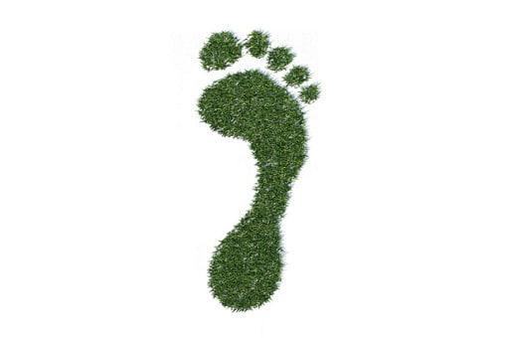

**Creator: Carmela Menna**

**Student profile:** 26 students, aged 11-12.

They work in teams and cooperate in order to share ideas and opinions.

They use the target language in the foreign language lessons.

They use several digital tools in classroom, thanks to the interactive whiteboard, and in computer room.

**Language level:** Language level: **A2** *(based on the common European framework reference for languages)*

**Duration: 3** teaching periods

**Individual occupation time:** 5-6 hours

**Requirements and Prior Knowledge:** Classroom with interactive whiteboard or projector and internet connection, personal smartphone (one per group).

Knowledge of internet navigation and use of Web 2.0. tools.

**Brief description of the scenario**

Starting from the point that humans need food, shelter and heating (in some locations) to survive and our planet’s ecological resources help fulfill these needs, I asked my students: “how many resources do we consume?” This question can be answered using the Ecological Footprint.

**1st teaching period**

**1st Activity:** discussion about resources

Time: 15’

Type of activity: discussion

Class organisation: discussion in class

Actions/Tasks: the teacher presents the topic and asks questions to pupils to understand their foreknowledge.

“Are all the countries of the world developed in the same way?”

“which are the most developed countries”

“what does <<more developed countries>> mean”?

“do we respect the nature and resources that Earth offers us?”

At the end the teacher asks:

WHAT IS AN ECOLOGICAL FOOTPRINT?

By definition, an ecological footprint is:

“the impact of a person or community on the environment, expressed as the amount of land required to sustain their use of natural resources.”

Basically, your ecological footprint is a holistic look at your resource usage. It’s used to calculate how many earths would be required if everyone on the planet lived like you.

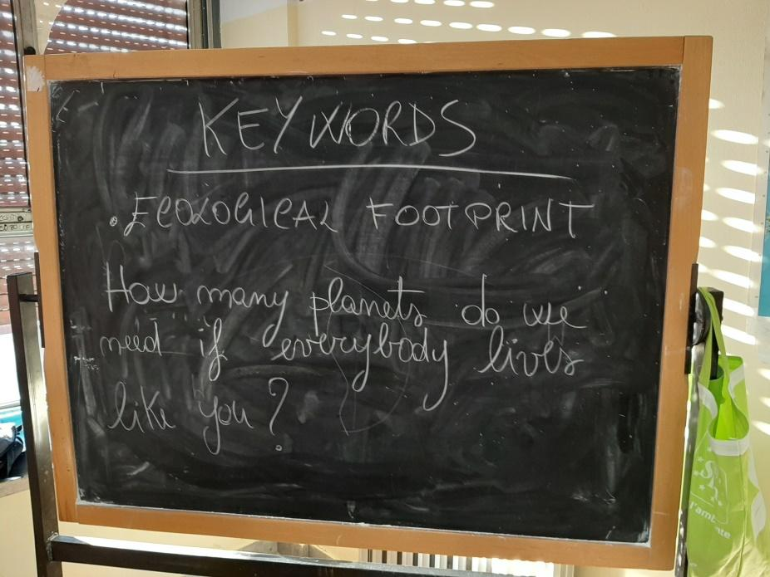

**2nd Activity:**

Time: 35’

Type of activity: fill the questionaire on the website

Class organisation: discussion in class

Actions/Tasks: at the whiteboard the teacher with her pupils fill the questionaire on the website <https://www.footprintcalculator.org/>

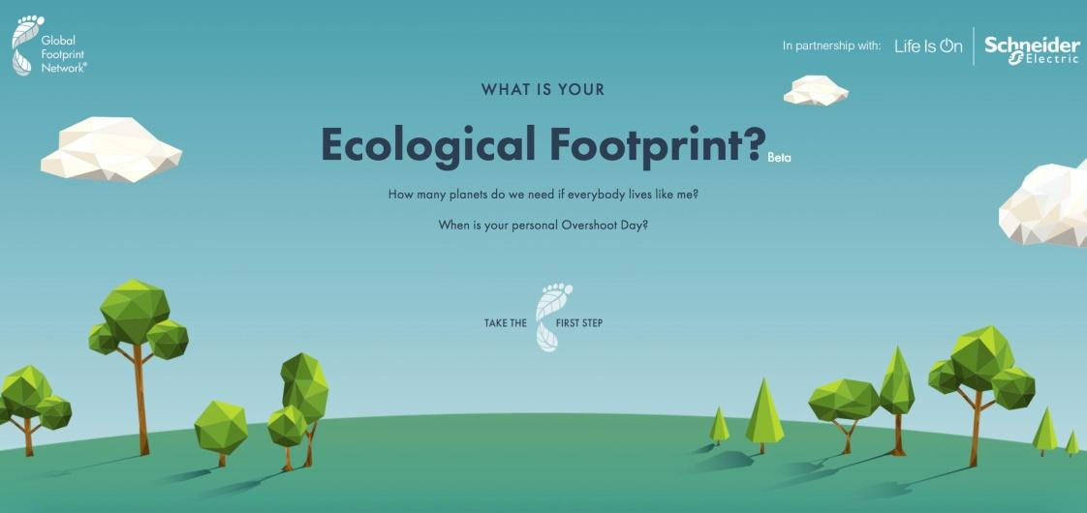

At the end of the questions they discover how many planets we need if everybody lives like you and when is predicted your personal Overshoot Day.

The results revealed that if everyone lived like us, our personal Earth Overshoot day would be on 15th May 2020.

Therefore we would need 2.7 Earths.

The Ecological Footprint can be calculated for a single [individual](http://www.footprintcalculator.org/), [city](http://www.footprintnetwork.org/our-work/ecological-footprint/cities/?__hstc=207509324.761dbcd53882f12471f4391079f4d0c9.1583143837068.1583143837068.1583143837068.1&__hssc=207509324.1.1583143837071&__hsfp=1878041166), region, [country](http://www.footprintnetwork.org/countries/?__hstc=207509324.761dbcd53882f12471f4391079f4d0c9.1583143837068.1583143837068.1583143837068.1&__hssc=207509324.1.1583143837071&__hsfp=1878041166) and the entire planet.

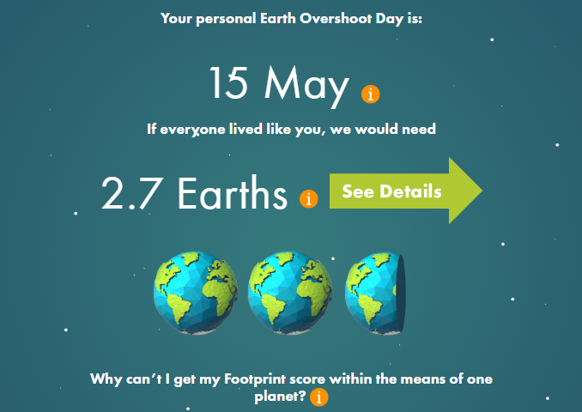

**3rd Activity:**

Time: 10’

Type of activity: division of the class into 6 groups

Class organisation: discussion in class

Actions/Tasks: the teacher divides the pupils into 6 groups of 4-5 students and explains the work to be done at home. Each group will have to do 3 interviews with friends and relatives, if possible in English, and report the answers in the attached form “INTERVIEWS.xlsx” which will be used to make a statistic.

**2nd teaching period**

**1st Activity:** discussion about work at home

Time: 10’

Type of activity: discussion

Class organisation: discussion in class

Actions/Tasks: teacher asks to pupils how they worked at home and if they had difficulties with English or with group work management.

**2nd Activity:**

Time: 50’

Type of activity: video projection, discussion and self-assessment of the work

Class organisation: discussion in class

Actions/Tasks: The working groups project one of the three interviews they did on the interactive whiteboard, compare themselves with the rest of the class and do a self-evaluation of their work

**3rd teaching period**

**1st Activity:** explanation

Time: 5’

Type of activity: work organization and discussion

Class organisation: discussion in computer lab

Actions/Tasks: The teacher arranges the pupils for the groups already formed in the previous lesson to the personal computers of the computer lab and explains that they have to make graphs of the interviews they have done. Then a group will be formed consisting of a representative of each group who will work on the results obtained by each group and create a single graph.

**2nd Activity:**

Time: 30’

Type of activity: elaboration of charts with excel

Class organisation: groups in the computer lab

Actions/Tasks: the pupils divided into groups attribute a scale of values from 1 to 5 for the answers to the interview questions.

1=very low impact, 2= low impact, 3= moderate impact, 4= high impact, 5= very high impact. Then they elaborate the data making graphs.

**3rd Activity:**

Time: 25’

Type of activity: a group will be formed consisting of a representative of each group

Class organisation: groups in the computer lab

Actions/Tasks: pupils process data by making histograms with the Excel program. The results can be found in the "interview charts" file .xlsx .