

**“Make it groove!”**

**John Bonham – The God of Rock Drums**

Drums and percussion teaching at lower secondary school

Creator: Fazzari Marco

Students profile: aged between 12 and 13 years old, pupils love to share their passion for music and drums working in groups, activating cooperative learning strategies and making brainstorming on the topic mastered.

They attend classes in a music room and use percussion instruments and systems provided by the school. Thanks to LIM, TABLET, PC they can have free access to the OER (open educational resources) shared by the teacher, and work on it using digital platform such as Google Classroom.

Students have basically an A2 English level.

Lessons: the course will last 4 hours divided into 4 meetings.

Competences:

* drums rudiments, stick control technique and 4 way (hands and feet) coordination
* critical ability and application
* sound recording
* use of software and digital skills

This project will be attended by students from the 3rd year of lower secondary school.

At the end of the study program, each pupil will be playing and recording a drums groove inspired to John Bonham’s tracks recorded with the band Led Zeppelin.

**LESSON 1**

INTRODUCTION

Time: 15 min

Activity: project presentation.

LED ZEPPELIN

Time: 45 min

Activity: brief history, ear training.

The students will work in groups to analyse and focus on the main cultural and historical aspects that brought to the birth of rock music and a band like Led Zeppelin.

Then, under the teacher guide, they will listen some of the most important and characterizing grooves and songs that made John Bonham’s legacy so precious to all rock drummers: “Good times bad times”, “Immigrant song”, “Fool in the rain”, “Moby Dick”.

Objective: to make a reflection on the historical and cultural context where rock music was born, underlining the influences of this music in Europe and the rest of the world. Students will furthermore improve their critical skills and cooperate and collaborate in their learning.

<https://www.youtube.com/watch?v=rNql6xNdCaE&t=744s>

<https://www.youtube.com/watch?v=U_E1kDfJskM>

**LESSON 2**

Activity: “Good times bad times!”

Time: 60’ min

Type of work: groove transcription and technical approach. Brainstorming.

The students will analyse the drums patterns that characterize the groove of the song “Good times bad times” by Led Zeppelin. After made a basic transcription on their pentagram, they will compare their work in groups trying to understand what’s correct and what is not.

After teacher supervision, students will start to practice drum patterns and exercise to develop:

* Triplets feeling
* Bass drum pedal technique
* 4 way coordination
* Sound concept

Objective: The goal of this lesson is to develop the skill to understand by listening (ear training) what the drummer is playing in a song. Thanks to transcription work, the students can confront themselves acquiring a deeper understanding of what they’re listening to. Then, the practice on drums is what definitely underline the passage from knowledge, to skill, to real competence.

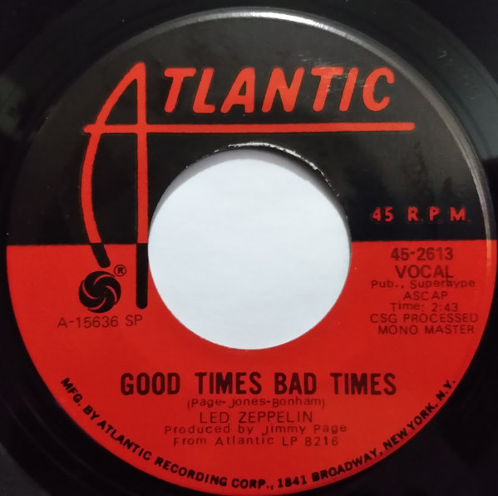

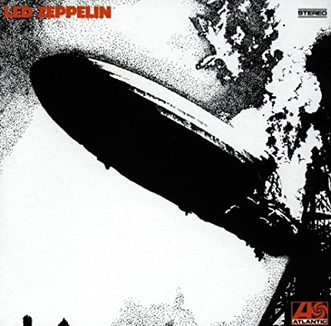

Led Zeppelin vynil record

Led Zeppelin, “Led Zeppelin” album cover (1969), Atlantic Records

[**https://www.youtube.com/watch?v=G1rJohGD9LA**](https://www.youtube.com/watch?v=G1rJohGD9LA)

[**https://www.youtube.com/watch?v=m6wRXeqp36M&t=177s**](https://www.youtube.com/watch?v=m6wRXeqp36M&t=177s)

[**https://www.youtube.com/watch?v=1aEz6B7wRfA**](https://www.youtube.com/watch?v=1aEz6B7wRfA)

[**https://www.youtube.com/watch?v=nHdXtDUHWWU**](https://www.youtube.com/watch?v=nHdXtDUHWWU)

**LESSON 3**

Activity: rehearsals

Time: 60’ min

Type of work: groove practice and 1st recording session.

The students will practice the drums groove and patterns, improving their skills.

They will furthermore get in contact with all the technology needed to make the recordings: microphones, cables, audio card, digital audio work station (Cubase).

Objectives: helping each other, the students will develop their ability to work in groups, sharing their point of views and their energies to practice and getting better on the instrument.

After practice, the students will make a first recording session to notice their musical progresses and to start learning how application software used for recordings works.

**LESSON 4**

Activity: recording session and assessment

Time: 60’ min

Type of work: overdub the drums part on the minus drum track

The students will record their personal drums interpretation of John Bonham’s groove on “Good times bad times”.

Thanks to this activity they will improve many technical and psychophysical aspects:

* Time keeping (internal clock and breathing)
* Balance (in body movement and sound production)
* Concentration and application

Objective: this experience will bring the students to a higher level of consciousness about how music works, thanks to the possibilities given from the listening of their own recordings and to the auto-evaluation they can make on their playing.

At the end of the lesson, students will also complete a questionnaire made with Wordwall application.

<https://wordwall.net/it/resource/29393812>